
Edexcel History

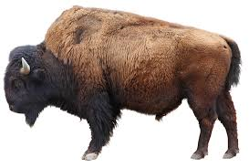

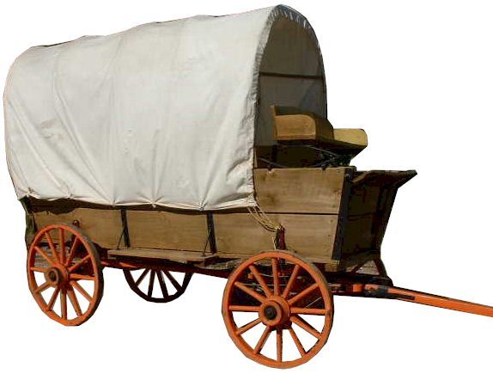
Period Study: The American West, c.1835 to c.1895

Revision Guide
Questions on the exam
Question 1: Explaining Consequences (8 marks)
- Question 1 focuses on consequences - things that happened as a result of something
- The question asks you to explain the consequences of an event, NOT its causes
- This question is worth 8 marks, so allow 10 minutes for this question
- You have to explain two consequences and each consequence is worth 4 marks.
Example Questions:
- Explain two consequences of the setting up of the Oregon Trail (1836).
- Explain two consequences of the Fort Laramie Treaty (1851).
- Explain two consequences of the Homestead Act (1862).
- Explain two consequences of the development of ranching on the Plains in the years 1866-76.
- Explain two consequences of the winter of 1886-87 for the cattle industry.
- Explain two consequences of the end of the open range.
- Explain two consequences for Native Americans of the Dawes Act (1887).
- Explain two consequences for settlement of the West of the opening of the Transcontinental Railroad (1869).
- Explain two consequences for settlement of the West of the discovery of gold in California (1849).
- Explain two consequences for settlement of the West of the Pacific Railroad Act (1862).
- Explain two consequences of the Timber and Culture Act (1873).
- Explain two consequences of the introduction of barbed wire in the West (1874).

How to answer the question

Step | What to do
1 | Suggest one thing that happened as a result of the event mentioned in the question …. “One consequence of [event in question] was…
2 | Add contextual own knowledge when you make a point. “This is supported by my contextual knowledge…”
3 | Fully explain this consequence. Use your own knowledge of the period to support your answer with specific examples. (3-4 sentences)
4 | Introduce your next consequence. “Another consequence of [event in question] was..
5 | Repeat steps 2-3

Question 1 - Tips
- Refer to the word consequence in your answer - it shows examiners you’re answering the question!
- Use phrases such as ‘as a result’ & ‘the effects of this was’ to show examiners you are explaining.

Synonyms (similar words) of the word: Consequence
- Outcome, result, effect, ramification

Question 2: Writing Analytical Narrative (8 marks)
- Question 2 asks you to provide an analytical narrative - an analysis of causation, consequence OR change.
- You will need to explain and analyse key events using historical concepts.
- You need to link events together and explain how one leads to another in a logical and structured way

Example Questions:
- Write a narrative account analysing the ways in which the cattle industry grew in the years 1865-1874. You may use the following in your answer:
  - The Goodnight-Loving trail (1866)
  - The introduction of barbed wire (1874)
You must also use information of your own.

- Write a narrative account analysing analysing the ways in which the US government policy towards the Plains Indians developed in the period 1835-51.
You may use the following in your answer
  - The Permanent Indian Frontier (c.1834)
  - The Indian Appropriations Act (1851)
You must also use information of your own.

- Write a narrative account analysing the ways in which settlement in the West developed in the years 1876-1895.
You may use the following in your answer
  - The The Exoduster movement (1879)
  - The Oklahoma Land Rush (1893).
You must also use information of your own.

How to answer the question

Step | What to do
1 | Use the first prompt given to begin your answer.
2 | Analyse your points fully by giving an explanation for why or how an event took place as a result of the prompt provided.
3 | Make sure to organise your answer into chronological order. Write 3-4 sentences analysing the first prompt
4 | Link your first paragraph to the second prompt given.
5 | Repeat steps 2 and 3
6 | Add a third paragraph of your own knowledge (remember this must be in chronological order)
7 | Repeat steps 2 and 3
NOTE - if your own knowledge comes before either or both prompts in the question - reorder the answer to make it chronological.

Synonyms (similar words) of the word: Analysis
- Study, examination

Question 3: Explaining Importance (16 marks)
- Question 3 asks you to provide an analysis of consequence and significance - how important?
- This question is not asking for a description of an event or policy. It is asking why that event or policy was important
- This question is worth 16 marks
- You have to answer two of the three bullet points. EACH is worth 8 marks.

Example Questions:

- Explain two of the following
  - the importance of the Oregon Trail for the early settlement of the West.
  - the importance of the Indian Appropriations Act (1851) for the way of life of the Plains Indians.
  - the importance of the development of new mining towns for law and order in the early West.
- Explain two of the following
  - The importance of the opening of the First Transcontinental Railroad (1869) for the settlement of the West.
  - The importance of the winter of 1886-87 for the cattle industry.
  - The importance of the Dawes Act (1887) for the way of life of the Plains Indians.

- Explain two of the following
  - The importance of cattle trails for the development of the cattle industry in the 1860s.
  - The importance of the railroads for changes in the way of life of the Plains Indians.
  - The importance of the wagon trails for the early settlement of the West.

How to answer the question

Step | What to do
1 | Read the options carefully. Remember for each development you choose that the focus is its importance for a further factor and/or event.
2 | Choose one of the options to begin your answer.
3 | Fully explain the option. Use your own knowledge of the period to support your answer with specific examples. (5-6 sentences)
4 | Fully analyse its importance or significance on the second part of the same option. (5-6 sentences)
5 | Choose a second option
6 | Repeat steps 3 and 4

Synonyms (similar words) of the word: Important
- Significant, vital, imperative, critical, key, critical

Revision Topic Checklist: The American West, c.1835-c.1895

Topic | R | A | G
Key topic 1: The early settlement of the West, c1835 - c1862
The Plains Indians: their beliefs and way of life …
Social and tribal structures, ways of life and means of survival on the Plains.
Beliefs about land and nature and attitudes to war and property.
US government policy: support for US westward expansion and the significance of the Permanent Indian Frontier. The Indian Appropriations Act 1851.
Migration and early settlement: The factors encouraging migration, including economic conditions, the Oregon Trail from 1836, the concept of Manifest Destiny, and the Gold Rush of 1849.
The process and problems of migration, including the experiences of the Donner Party and the Mormon migration, 1846-47.
The development and problems of white settlement farming.
Conflict and Tension: Reasons for tension between settlers and Plains Indians. The significance of the Fort Laramie Treaty 1851.
The problems of lawlessness in early towns and settlements.
Attempts by government and local communities to tackle lawlessness.
Key topic 2: Development of the plains, c1862 - c1876
The development of settlement in the West: The significance of the Civil War and post war reconstruction, including the impact of the Homestead Act 1862, the Pacific Railroad Act 1862, and the completion of the First Transcontinental Railroad, 1869.
Attempts at solutions to problems faced by homesteaders: the use of new methods and new technology; the impact of the Timber Culture Act 1873 and of the spread of the railroad network.
Continued problems of law and order in settlements, and attempted solutions, including the roles of law officers and increases in federal government influence.
Ranching and the cattle industry: The cattle industry and factors in its growth, including the roles of Iliff, McCoy and Goodnight, the significance of Abilene and of the increasing use of the railroad network.
Rivalry between ranchers and homesteaders.
Changes in the way of life of the Plains Indians: The impact of railroads, the cattle industry and gold prospecting on the Plains Indians.
The impact of US government policy towards the Plains Indians, including the continued use of reservations. President Grant’s ‘Peace Policy’, 1868.
Conflict with the Plains Indians: Little Crow’s War (1862) and the Sand Creek Massacre (1864), the significance of Red Cloud’s War (1866-68) and the Fort Laramie Treaty (1868).
Key topic 3: Conflicts and conquest, c1876 - c1895
Changes in farming, the cattle industry and settlement: Changes in farming: the impact of new technology and new farming methods.
Changes in the cattle industry, including the impact of the winter of 1886-87. The significance of changes in the nature of ranching: the end of the open range.
Continued growth of settlement: the Exoduster movement and Kansas (1879), the Oklahoma Land Rush of 1893.
Conflict and Tension: Extent of solutions to problems of law and order: sheriffs and marshals. The significance of Billy the Kid, OK Corral (1881), Wyatt Earp.
The range wars, including the Johnson County War of 1892.
Conflict with the Plains Indians: the Battle of the Little Big Horn, 1876 and its impact; the Wounded Knee Massacre, 1890.
The Plains Indians: the destruction of their way of life: The hunting and extermination of the buffalo.
The Plains Indians’ life on the reservations.
The significance of changing government attitudes to the Plains Indians, including the Dawes Act 1887 and the closure of the Indian Frontier.

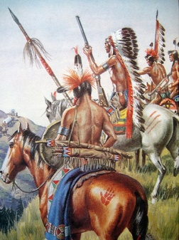
The Plains Indians
Many different tribes lived on the Great Plains. Some tribes like the Sioux were big enough to be called nations. Some tribes were enemies whereas others were traditional allies. Each tribe was made up of bands which could be just 20 or 30 people or as many as several hundred. The different bands in a tribe worked together and met for a big tribal camp council each summer.
Chiefs & Councils
Chiefs were the leaders of the Plains Indians society. There could be many types of chiefs, a war chief, a spiritual chief etc. Chiefs were always men. Whites found it hard to understand the tribal political structure. There was no single system for choosing chiefs. They were not chiefs for life but emerged and then went as their skills rose and faded. Each band had a chief, band chiefs and elders made up the tribe’s council when it came together. Some bands might follow one chief and others might follow another. Chiefs could not command people to do what they said. In a tribal council everyone could give their opinion and all were listened to.
Warrior Brotherhoods
There were several of these in a tribe and young men joined them after proving their bravery and skill in fighting. The brotherhoods trained young men in fighting, they did not have to obey the tribal council in many Plains tribes so they may break peace treaties. The brotherhoods organised the buffalo hunt and made sure the old and ill were fed.
WOMEN COULD NOT BE CHIEFS and a successful man could have more than one wife but women were valued because they were in charge of making products out of the buffalo and they were valued for their skill in doing this.
Survival on the Great Plains –
The Plains have very hot summers and freezing winters. Survival depended on hunting buffalo. So Plains Indians developed –
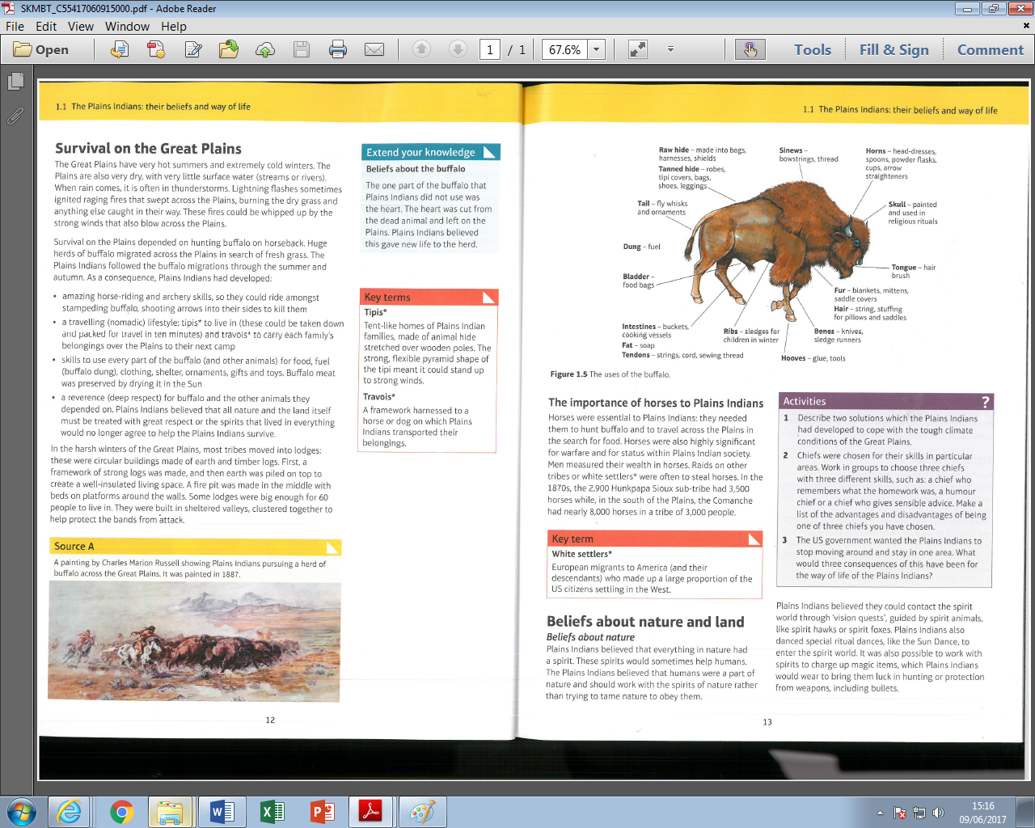
- Brilliant horse-riding and archery skills.
- A nomadic lifestyle – tipis could be collapsed and carried by a travois which was harnessed to a horse or dog.
- A real skill for using every part of the buffalo.
- A great respect for the buffalo and other animals.
In harsh winters the Native Americans moved into lodges made of earth and timber logs. They had a fire pit in the middle and beds on platforms around the walls. They were well insulated with earth piled on top. Some lodges were big enough for 60 people to live in and were constructed in sheltered valleys.
Horses
These were crucial to hunt the buffalo and move across the Plains. Horses were important for warfare and for status and tribes often raided other tribes or white settlers to steal their horses.
Spiritual Beliefs
They believed that everything in nature had a spirit. Plains Indians believed they could contact the spirits through vision quests guided by spirit animals like hawks or foxes. They danced special ritual dances to contact the spirits, like the Sun Dance.
Land was seen as sacred – ‘the mother’ of the Plains. Some lands like the Black Hills were especially sacred. The Lakota believed they had been created in the caves there by the Great Spirit. Some Indians farmed the land but most of the Plains Indians did not. They believed that land could not be bought and sold and should not be disrespected by farming and mining.
War

Fighting was important in order to get resources from other tribes to help survival on the Plains but because young men were so valuable several customs developed to minimise the loss of life through fighting. So a raid would only go ahead if it was likely to succeed and warriors would quickly retreat if it looked like the raid may fail. Also only selected brotherhood would go on a raid to reduce casualties. Counting Coup meant success it was a special type of fighting in which a warrior would attempt to hit or touch an enemy without being captured, injured or killed. It required a lot of skill and bravery and won a lot of respect.
Government policy towards the Indians
Most whites believed that the Plains Indians did not use the land as efficiently as they did so it was wrong that Indians should have good land. So the Indians should learn to farm or they should be moved off the land. Throughout the 19th Century there was a struggle over two approaches to the ‘Indian problem.’ 1) Keep white settlers and Indians apart. 2) Encourage Indians to become like whites.
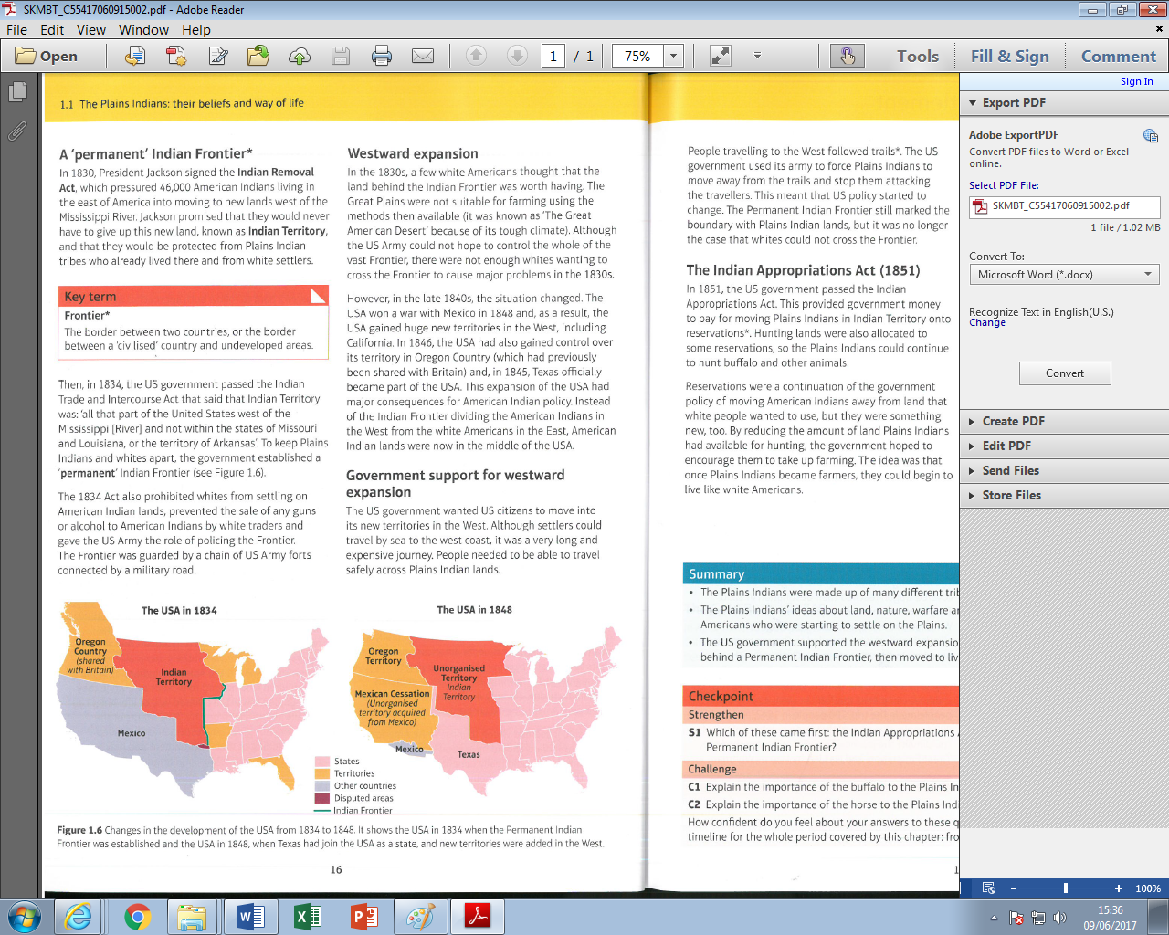
The Permanent Indian Frontier
1830 - Indian Removal Act - this forced 46,000 Indians to move to new lands west of the Mississippi river.
1834 - Indian Trade and Intercourse Act designated certain land as ‘Indian Territory.’ It established the Permanent Indian Frontier and said whites could not go on Indian land to try and keep the two peoples apart. The Frontier was guarded by a chain of U.S. Army forts.

When the U.S. gained more land after the Mexican-American War in 1848 the Indians were now stuck in the middle of American lands in the East and the West. His led to further problems.
The government wanted US citizens to move into the new western territories so people needed to cross the Plains where the Indians were. Now it was no longer the case that whites could not cross the Frontier. The government encouraged people to cross the Plains using trails and the army forced Indians away from these trails – so government policy was changing.
Indian Appropriations Act, 1851
This provided government money to move the Indians onto reservations. These were areas reserved for use by the Indians. Reservations were a continuation of policy to move Indians away from whites but they were also something new because by reducing the amount of land available for hunting they hoped to encourage the Indians to take up farming.
Push and Pull Factors in Migration to the West
Some factors pushed people to trek West but other factors pulled migrants to make the journey.
The Oregon Trail
The chance of free farmland in Oregon was a big pull factor. A way through the Rockies and Sierra Nevada mountain ranges was needed in order to get to Oregon over land. The Oregon Trail was a route through the Rocky Mountains and was first publicised in 1825 by Jedidiah Smith. The first migrants to travel the Oregon Trail with a covered wagon reached their destination in 1836. By 1869, when the Transcontinental Railroad became the main way of travelling west, 400,000 people had migrated along the Oregon Trail.
PUSH
In 1837 there was an economic crisis in the East which lasted until the mid-1840s. Banks collapsed, people lost their savings and unemployment was as high as 25%. Wages were cut by as much as 40%. So these circumstances gave people a good reason to move West and try and make a better life.
PULL
The government wanted to encourage people to move west to Oregon to establish the territory as U.S. land rather than sharing it with the British. They provided $30,000 for an expedition to map the Oregon Trail and publish reports that helped migrants and attracted people to go west.
The Gold Rush of 1849 saw 100,000 people head for California. This was because of the huge pull factor of gold being discovered. California’s population reached 300,000 by 1855. California’s population grew because of the food, equipment and services that gold miners needed. So the economic impact of finding gold provided jobs and business opportunities for many Americans. The Gold Rush promoted the image of the West where people could make a success of their lives and it led to a growth in farming in California. Money from the Gold Rush helped to pay for the first Transcontinental Railroad.
Manifest Destiny was a pull factor which was the belief that white Americans had the right to populate the whole continent.
The process and problems of migration
The journey to Oregon from the Missouri River was 3,200 km long and posed many problems.
- Any journey needed to be completed by winter so people were not stuck in the mountains in ice and snow.
- It was advised that journeys should not start until April so there was enough grass on the Plains for animals to eat.
- Food was needed for the whole journey – most people took slated pork as it did not rot for a long time.
- The best animals to pull the wagons were oxen but these were very slow and could only move at 3km an hour so setting off in April meant a tight time schedule to get through the mountains before winter.
- Most wagon trains had lots of wagons with at least 20 wagons and a range of people with many skills.
- There were big problems with falling ill or running out of supplies. Cholera was a big problem because each wagon train used the same spots to camp near rivers. People going to the toilet in these rivers and using them for drinking water ensured disease spread more easily.
- There was also the problem of attacks by Native Americans.
The Donner Party, 1846
- Lansford Hastings set up the Donner party to be part of a group of settlers who would inhabit California. Most settlers travelled to Oregon because it was a shorter trail, but Hastings wanted to take California from the Mexicans.
- He found a short cut but he had not been on it, it would save over hundreds of kilometres, but it would cause disaster.
- Most of the Donner party wanted to try this new route but some wanted to go along the usual route. As a result it split into two with 88 going with the Donners.
- The trail was dangerous and they had to find an alternative where they had to remove boulders and guide cattle through winding stretches.
- According to Hastings it should have taken them 2 days to cross the desert it took a week.
- They began to lose cattle in the desert (300 oxen dead) and Indians raided their stocks.
- Arguments broke out and one man, James Reed, killed another in self-defence. He was banished to the Desert.
- Food supplies began to run out and it was only September and they needed to cross the Sierras before snow fall.
- The snows had come a month early! Many of their cattle died of the cold and in the suffocation of the drifts.
- The first settler died of starvation. And the others were chewing on bones, twigs and barks of trees.
- They had to resort to cannibalism. Four of them died and the flesh was stripped from their bones, roasted and ate. All the pieces were labelled so that they did not eat their own wife or husband.
- Eventually some of them were rescued 23 were strong enough to be led out of the Sierras.
- Some had gone mad and the rest had died.
The Mormons
For one group of migrants their travel towards the frontier was motivated by religious persecution. In 1827 in Rochester, New York, Joseph Smith claimed he was visited by the angel Moroni who told him of the whereabouts of a Book of Mormons. Smith retrieved the volume and transcribed the story of two ancient and lost tribes of Israel who had made their way to America where the prophet Mormon had attempted to build a new, and true, church before being killed by the Native Americans. Smith published the Book of Mormons and in 1830 founded the Church of Jesus Christ of the Latter-Day Saints.

Smith and the Mormons moved west to Kirtland, Ohio where Brigham Young became one of their growing number of converts. Young and others set up a colony in Independence, Missouri. The Mormon’s religious zeal was combined with industry and determination and in Kirtland they built a mill, a store and a bank. They also aroused jealousy and hostility among non-Mormons, however. In one incident Smith was tarred and feathered. In 1838, following the financial downturn that the Mormons provided a convenient scapegoat for, the Missouri governor called out the militia against the Saints. The faithful moved to Nauvoo in Illinois where they succeeded in turning this frontier town built on a swamp into a thriving and populous city. It was during this time that God revealed to Smith that polygamy was acceptable. A revelation that was well received by many of the male Mormons as Nauvoo had a surplus of women. Smith and Young were among those who took multiple wives despite criticism from those within their own church. This was more than many non-believers could tolerate.

In 1844 Smith was arrested and thrown in jail. The prison in which he was incarcerated was stormed by a masked mob and Smith was martyred when shot at point-blank range. The leadership of the Mormons passed to Brigham Young who decided to take his followers to a new promised land further west after studying reports of the Oregon Trail. He set off at the head of a 600 strong party in 1846. They moved across Iowa to the Missouri River and camped as winter set in. That winter of 1846-7 was bitterly and brutally cold and hundreds died. It was during this same season that George Donner’s band of pioneers headed for California became snowbound in the Sierra Mountains where many perished and some resorted to cannibalism to stay alive.
As spring finally dawned in 1847 Young led a small group of pioneers further west in search of the Mormon promised land. Young took his party along the north of the bank of the Platte to avoid non-Mormons on the Oregon Trail. In July 1847 they rounded Big Mountain in the Rockies. They emerged onto the dry and fertile Great Salt Lake Valley. Exhausted from his journey, Young declared that this would be the Mormon’s new state. He named it Deseret meaning honeybee. There the Mormons, as they had wherever they had been, set about building a thriving and prosperous community.

Problems of white settlement on the Plains
In California and Oregon the climate and soil were good for farming. In the 1854 the government created two new territories that were behind the Permanent Indian Frontier. These territories of Kansas and Nebraska were on the Plains and were opened up for settlement but the conditions for farming there were very difficult.
Problems of farming on the Plains –
- Soil was really hard to plough and normal ploughs broke under the strain.
- Traditional crops that were planted in the East did not grow because the Plains were too dry in summer and too cold in winter.
- Prairie fires after long hot summers could lead to crops being burned.
- Vast clouds of grasshoppers spread swept across the Plains some years eating crops and polluting the water with their droppings.
Tensions
Plains Indians were often in conflict with other tribes over scarce resources. When white migrants on the Oregon Trail saw the Indian war parties they were scared and though the Indians were going to attack them. This was very rare but there was a fear of Native Americans that was fuelled by racism and prejudice against what white people thought were an inferior and uncivilised people. There was a lack of understanding between whites and Indians and a lot of mistrust.
Food Supply
Migrants sweeping West on the Oregon Trail disrupted Indian buffalo hunting and killed many Buffalo for meat along the trail. Oxen that were used to pull the wagons ate grass that the buffaloes and Indian horses needed to survive.
Fort Laramie Treaty, 1851
The US government organised a council with the Plains tribes to agree a treaty to stop conflict between migrants and Indians but there were problems with this –
- Government negotiators wanted the Sioux to pick a chief to represent them but this did not make any sense to the Indians because this was not how their tribal structure worked. The government chose a warrior called Conquering Bear to negotiate with but he was not a chief.
- Some tribes did not send any representatives.
- The treaty wanted to pin down precise boundaries to each tribe’s land but Native Americans did not see land like this.
- There were some serious translation difficulties with a treaty written in English.
The Fort Laramie Treaty agreed –
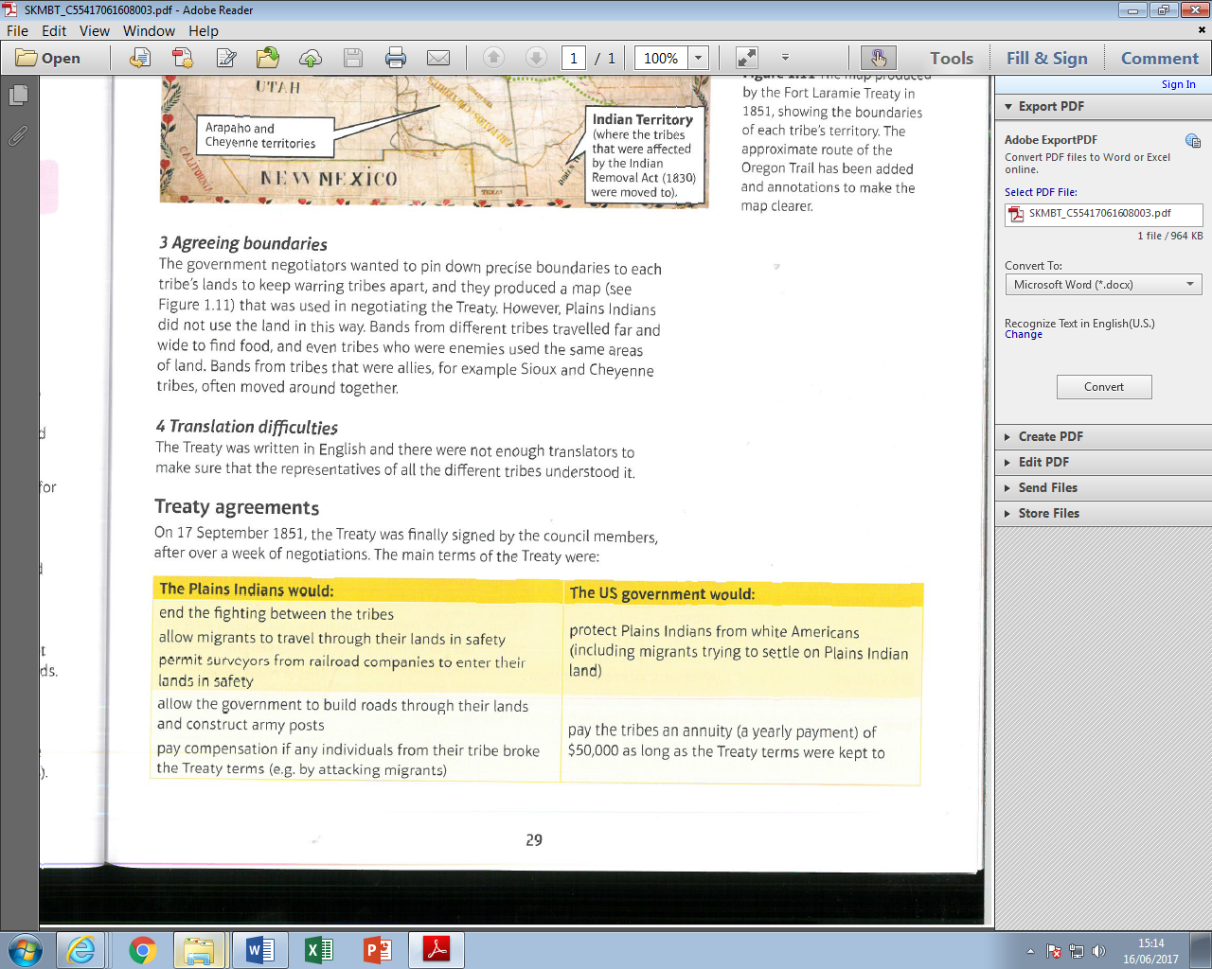
The Treaty was significant because:
- The Fort Laramie Treaty was the first step towards the establishment of reservations.
- The treaty said that migrants had to be allowed to travel safely across the Plains, this undermined the idea of the Permanent Indian Frontier.
- The government gave the Indians food and products if they allowed the migrants across the Plains – so they got things if they behaved how the government wanted them to.
The Treaty had problems because –
- There was no tradition for a tribe to be represented by one chief or do what he said, so the treaty was not seen as binding by the Indians.
- Because of translation problems not all Indians knew what they had signed up to.
- The boundaries of the tribes’ territories were not seen as fixed or meaningful.
Not surprisingly neither side had any lasting success at sticking to this Treaty and so further tension and conflict followed.

Law and Order in Early Towns and Settlements
During 1840s there was minimal lawlessness as migrant communities had to rely on each other to survive. This changed with the California Gold Rush and a mass increase in population. Mining camps where gold had been found quickly developed into settlements of thousands of men and this all happened too quickly for law enforcement to be introduced effectively.
- People tried to steal land that had been claimed by others when there was gold found there.
- Some people ‘salted claims’ they sprinkled a few flakes of gold in the water to make people buy the land even though there was no gold there. ‘Road agents’ waited on the roads out of camps to rob people.
- Alcohol and prostitutes led to fights often involving guns.
- Mining prospectors came from all over the world so there was often racial tension – Chinese migrants came to California after a famine in China in 1851. There were rivals gangs in San Francisco made up of men who could not find work. There was a lot of racism and whites often killed and stole from Chinese miners.

Attempts at law enforcement –
Until a territory reached a population of 60,000 it could not apply to become a state and was controlled by the federal government. The government appointed to each territory, a governor, three judges and a U.S. Marshal. Communities of over 5,000 could elect a Sheriff who, like a Marshal was responsible for every day law enforcement. Sheriffs and Marshals could invite men to join a posse to hunt down lawbreakers.
There were problems with this system –
- The geographical expanse of territories in the West meant it took a long time for law enforcement to get to areas where they were needed.
- The federal government did not pay law enforcement officials very much so many could be easily bribed by criminals.
- Sheriffs had no legal training and often favoured friends over others and so fuelling cases of injustice.

Mining camps and Vigilance Committees
Mining communities got together and agreed their own courts and judges to deal with disputes over claims.
These were better known as vigilantes and were a response to the crime wave in San Francisco in 1851. The rich people of San Francisco organised a vigilance committee of around 200 men that captured suspected criminals, tried them and punished them if found guilty. When the committee felt law and order had been restored they disbanded themselves. The idea of vigilantes spread quickly through mining towns in the West - these were often very effective.
The problem with vigilantes is that they often did not give people a fair trial, they sometimes lynched suspects and often used their power to settle scores in a less than fair way.
Racism
There were lots of crimes against Indians and Chinese people in the West but the white governments were also racist and so nothing was done to stop this. In fact Chinese miners had to pay higher taxes and suffer other discriminatory laws.
American Civil War and the Development of the West
The American Civil War claimed the lives of over 600,000 Americans and left the country devastated. Economic and Social changes in the South led to many people moving west to try and build a new life.
In the period leading up to the Civil War the free labour North had argued with the slave labour South about how to settle the new western territories. This caused much political conflict and few laws were passed. When southerner states left to form the Confederacy the government was controlled by the North and they pressed ahead passing laws to settle the West without argument from the South.
Homestead Act, 1862 - aimed at ensuring the West was settled by free men and women who owned and worked the land.
Pacific Railroad Act, 1862 - aimed at developing connections between the new lands of the West and the northern cities.
Homestead Act
Previously government and had been too expensive for ordinary people to buy. The Homestead Act made it more affordable. Applicants who paid a small filing fee ($10 - this was called filing a claim) were granted 160 acres of land in return for an agreement to reside on and farm the land for at least five years. Once they had lived on the land for five years and built a house and planted five acres of crops they could pay $30 and own their own homestead outright - this was called ‘proving up.’ Anyone over the age of 21 could file a claim - this included women and ex-slaves.
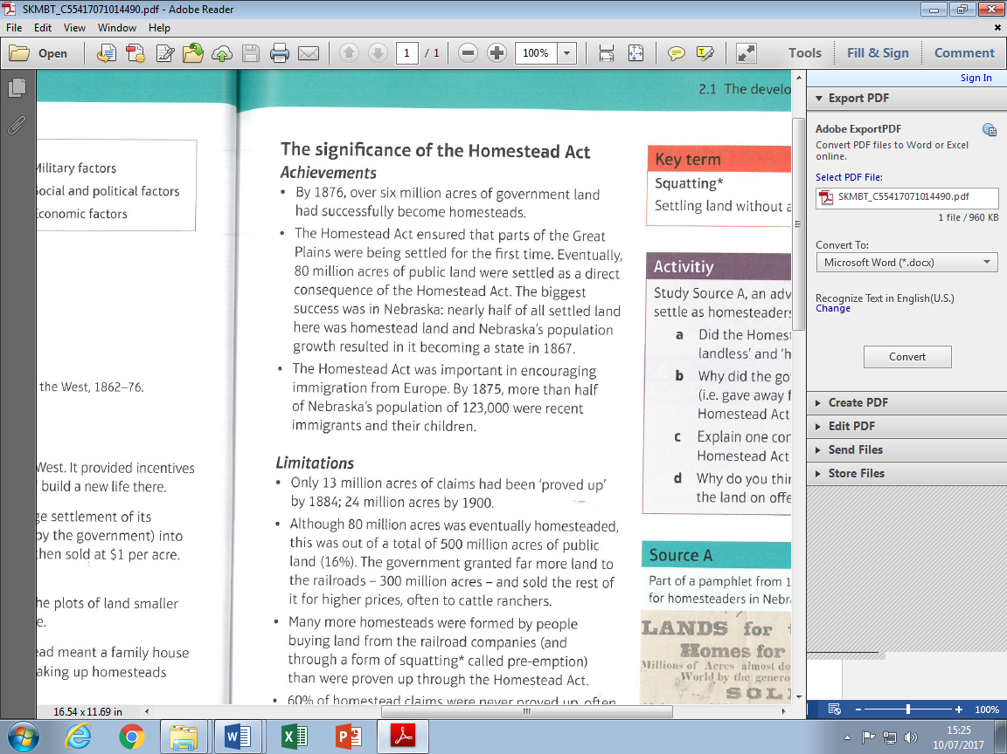
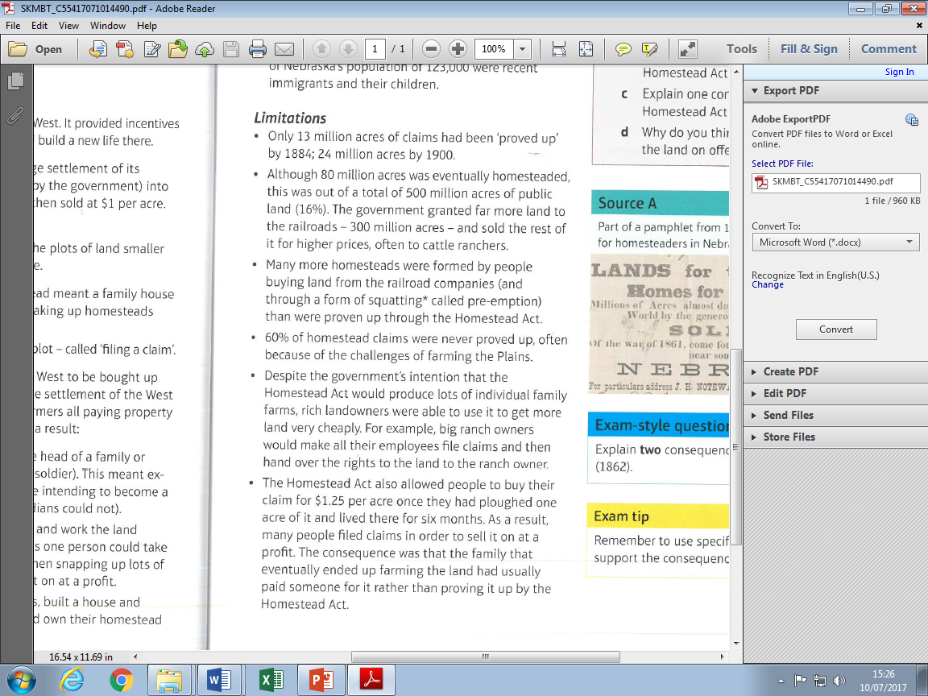

Pacific Railroad Act
The Pacific Railroad Act chartered the Union Pacific Railroad Company to build westward from Omaha and the Central Pacific Railroad Company to build eastward from Sacramento. The two companies raced to meet in the middle and see who could lay the most mileage of track. In 1868,
for example, the Central Pacific built 360 miles whilst the Union Pacific laid 425 miles of track.
The Pacific Railroad Act also set up the first electronic telegraph that ran alongside the tracks. The federal government and the states through which the rails ran gave millions of acres of land grants to railroad companies. These were then sold to settlers and prospectors to help finance construction costs. The government also committed to paying the companies $16,000 for every mile of track they laid. Native American rights to land along the route were ‘extinguished.’ Despite all the free land and loans of money the two companies were given they still both nearly went bust.

Railroads had a very big impact on the settlement of the West:
The more people that settled in the West the more rail traffic that would be generated and the companies building the railroads had millions of acres of land grants that they could sell. The Northern Pacific, Burlington and Missouri and Southern Pacific were among those who invested considerable funds in promoting life in the West in order to attract settlers from the East and Europe. Railroad companies offered inducements such as credit sales, free land exploring tickets, temporary accommodation and even agricultural training to those who wanted to start a new life in western lands.
Civil War veterans were attracted to the railroad colonies looking for a new start in life. Entire congregations of churches came from England to settle in the towns built by the railroad companies. These companies also attracted settlement in the West because of the economic opportunities that were opened up as tracks stretched further into western lands. The Illinois Central brought south-eastern Dakota within settling distance of Chicago by 1870. In 1873 the Chicago and north-eastern railroad also stretched into the Dakotas. These lines attracted settlers and also allowed farmers to sell to markets in the East. It was this developing transportation network that made commercial farming profitable and therefore encouraged migration.
In 1879 the Great Northern Railroad was founded but had no land grant and so had to depend on traffic and movement of people to develop revenue. As the Great Northern line made creeping progress through the Dakotas in stages immigrants were brought from Europe to populate the towns that developed. Model farms and homes were built for settlers. Money was loaned to farmers as feeder lines were added to the main railroad. Thousands of migrants flooded onto the Plains of North Dakota because of the colonisation efforts of the Great Northern Railroad.
In 1885 the Union Pacific Company posted special rates of $45 from the Missouri River to Portland, Oregon complete with a free baggage allowance. The Northern Pacific encouraged whole neighbourhoods to go west. They built reception houses for the trains full of new settlers and sold ready-made homes with an offer of a 10% down payment and then annual instalments until they were purchased outright. In 1894 the Great Northern Railroad encouraged a colony of Dunkers – German Baptist Brethren – from Indiana to move to North Dakota. A special train for them was chartered and carried a banner on the carriages as it passed through Indiana, Illinois and Wisconsin. As the train ran along the tracks people saw the message, “from Indiana to the rich, free lands in North Dakota, the bread basket of America.” The Dunkers were settled in North Dakota and began wheat farming. Without the construction of railroads these and thousands of other settlers would not have made new lives in the West.
The impacts of the railroads on settlement in the west were huge …
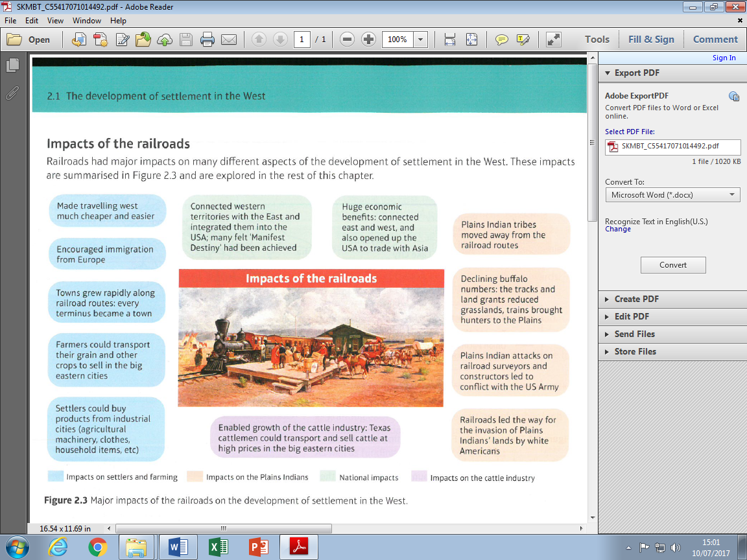

How did Homesteaders deal with the problems of farming on the Plains?
Although the publicity made homesteading seem relatively easy in reality there were huge challenges because of the harsh environment of the Plains. Many homesteaders also ran out of money and had to move back east.
RAILROADS made homesteading easier because …
- They could transport things and visit people more easily.
- They could order manufactured products – most were ordered from the Chicago-based ‘Sears Roebuck & Company’ catalogue.
- Towns sprang up close to railroads which provided a place for people to meet and sell goods.

Timber & Culture Act, 1873
- It became clear throughout the 1860s that 160 acres was not enough land to make homestead farms viable. In 1873 the Timber Culture Act attempted to offer additional land. Claimants could apply for an extra 160 acres if they planted trees on at least a quarter of the acreage within four years.
- Trees helped to create a wind break on the Plains to shelter crops, they provided timber for settlers to use to build houses and they also provided settlers with fuel.
- Sixteen million acres had been claimed under this Act by 1878, adding 50% more land to that claimed under the Homestead Act. But the legislation was criticised because often people claimed land that they had no intention of settling and then waited a few years for the price of the land to rise before selling it on.
New Inventions - There were some important inventions that helped make homesteading easier.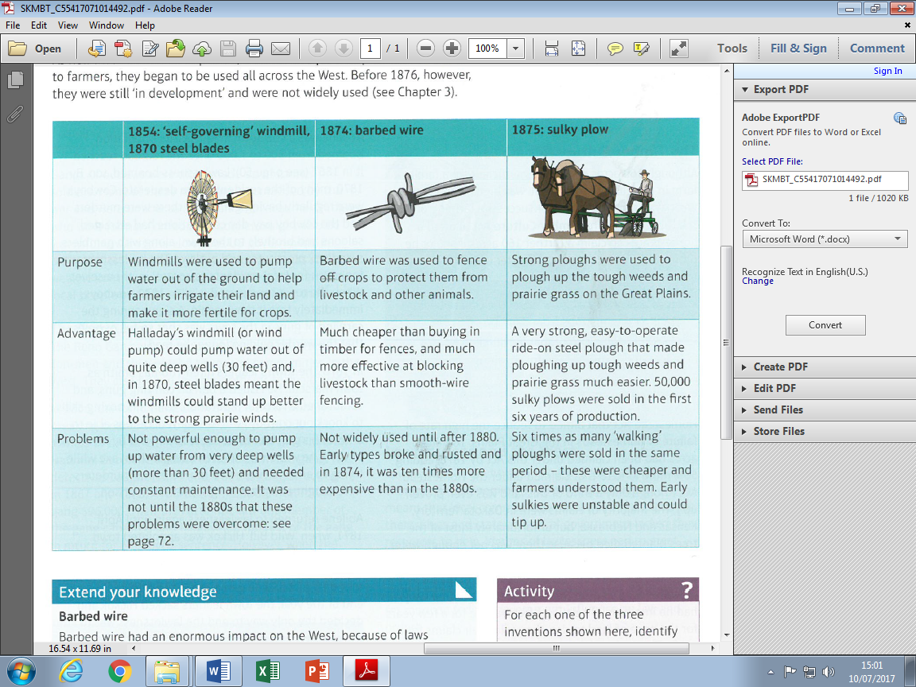
New Crops - The Mennonites were a religious community from grasslands in Russia who were persuaded to move to the US. They discovered that TURKEY RED wheat grew well on farms in Kansas because it could cope with the weather on the Plains.

Law and Order Problems
New towns stimulated by the railroads were lawless places, often known as ‘Hell on Wheels.’ This was particularly the case in cow towns where cows were loaded onto railroad wagons. Cowboys got paid and then went out on the town to celebrate.
Abilene was a typical cow town whose population grew with the railroads. Cowboys made the place lawless and the local residents could not control them. They tore down the jail and shot holes in a sign warning of a prohibition of the carrying of guns. In 1870 the town hired Thomas Smith as marshal. He was a boxer and a tough guy who managed to restore order until he was killed trying to arrest a suspect. Lawlessness returned until 1871 when ‘Wild Bill’ Hickok was appointed as town marshal. He was tough and respected but he spent most of his time gambling rather than enforcing law and order. The people in the town decided the only way to do this was to stop the cowboys from coming to the town in the first place.
After the Civil War …
There was more lawlessness because deserters and ex-soldiers entered the West. Gangs of outlaws were often made up of ex-soldiers, many of these were Confederates who resented the US government that had defeated the South.
The Reno Gang were a group of Civil War deserters. In 1866 they carried out a train robbery getting away with $16,000. The train company hired the Pinkerton National Detective Agency that hunted down and caught John Reno. But the gang struck again in 1867 and 1868. A fourth train robbery saw them steal $96,000. As the Pinkerton Detectives were about to finally arrest the gang a group of vigilantes turned up, took the men and lynched them.
Not all of the West was lawless and most crime, even in the wildest cow towns, was theft rather than murder.
Ranching and Cattle
Texan cowboys herded cattle on long drives up through Missouri where cattle were then transported to the East before the Civil War. But the Texas fever disease carried by the cattle made farmers in Missouri and Kansas opposed to cattle drives across their land. Quarantine laws and vigilance committees put a block on the cattle drives and by 1859 on the eve of Civil War Texans were looking for new routes for cattle drives.
During the Civil War, whilst young men were away fighting the Union (North), vast herds continued to grow scattered across the wilds of Texas. The longhorns were unbranded and unfenced and there for the taking by a team of skilled horsemen with ambition. In 1866 spontaneous cattle drives northwards in search of markets were stopped by Kansas and Missouri farmers who did not want their land trampled by cattle. They also feared the Texas fever livestock disease that was carried by ticks on the longhorns. Furthermore, in the aftermath of the Civil War with sectional feeling still running high, these Union farmers were hostile to the Confederate Texans and their cattle. BUT there was major money to be had - a cow worth $5 in Texas was worth $40 in Chicago and other eastern cities where beef was in high demand.
Illinois businessman Joseph McCoy realised that what was needed to make this “long drive” of steers profitable was an open route from cattle country to a railroad point where the livestock could be shipped to the East. In 1867 after a long search for a suitable location he found Abilene near the end of the Kansas Pacific rail line. It was a small and sleepy place but it was west of settled farming land and was close to a river from which the cattle could drink. Most importantly it had a railroad line with direct links to the East. Furthermore, Kansas had relaxed quarantine laws in 1867 allowing Texan cattle to be driven through the western party of the state. This is where Abilene was.
McCoy bought a tract of land and built a shipping yard, a barn, an office and a hotel. From here 36,000 head of cattle were shipped to Chicago in the first year of McCoy’s enterprise.
The Chisholm Trail, named after trail boss Jesse Chisholm, stretched from Abilene all the way south to Texas. There were grasslands along the whole trail for the cattle to feed on. McCoy assiduously advertised the route and his new “cow town” to Texas ranchers. By 1870 there were 300,000 cattle moving through the shipping pens of Abilene which had grown in size and population with ten boarding-houses, ten saloons and four hotels.
The Goodnight-Loving Trail
The success of Abilene led to the emergence of new trails and opened new markets to Texan cattle. The Goodnight-Loving Trail was named after Charles Goodnight and his business partner and ran through New Mexico Territory into Colorado and Wyoming.
Goodnight and Loving drove 2,000 cattle through hostile Comanche Indian territory where they were able to sell 800 cattle for £12,000 to the army fort - this was four times what they would have been worth in Texas. Goodnight returned to Texas to get more whilst Loving moved north and sold the rest to John Iliff who made a successful business selling beef to government workers and reservations in Colorado and Wyoming.
By 1876, Goodnight was so successful that his ranch in Texas had expanded to one million acres.
Ilif and Ranching on the Plains
In 1861 John Iliff bought a herd of cattle for $500. In the same year Colorado territory had been created after a gold rush in the Rocky Mountains. Denver City was created and sold supplies to the gold prospectors, so there was also a demand for meat but Denver had no rail connection.
Iliff saw an opportunity - he could fatten his herd up on the grassland of the Plains and sell the meat to the mining town without any of the expense and difficulty of the long drives.
By 1870, Iliff had a ranch of 26,000 cattle near Denver. He used the Homestead Act to build up a patchwork of claims until his ranch was 16,000 acres. He became Denver’s first millionaire.
What was crucial was that he had reared the majority of his herd on the Plains rather than relying on the cattle driven up from Texas. This was the start of a new phase in the cattle industry - RANCHING on the OPEN RANGE.
Cattle Barons
The 1870s was a time of the ‘beef bonanza.’ The open range was where the big money was - there was free grass on the Plains and plenty of money to be made selling meat back to the East and to Indian reservations and army forts in the West. The best way to make money was to have a huge ranch with loads of cattle so a few rich cattle barons became very influential and defended their interests fiercely.
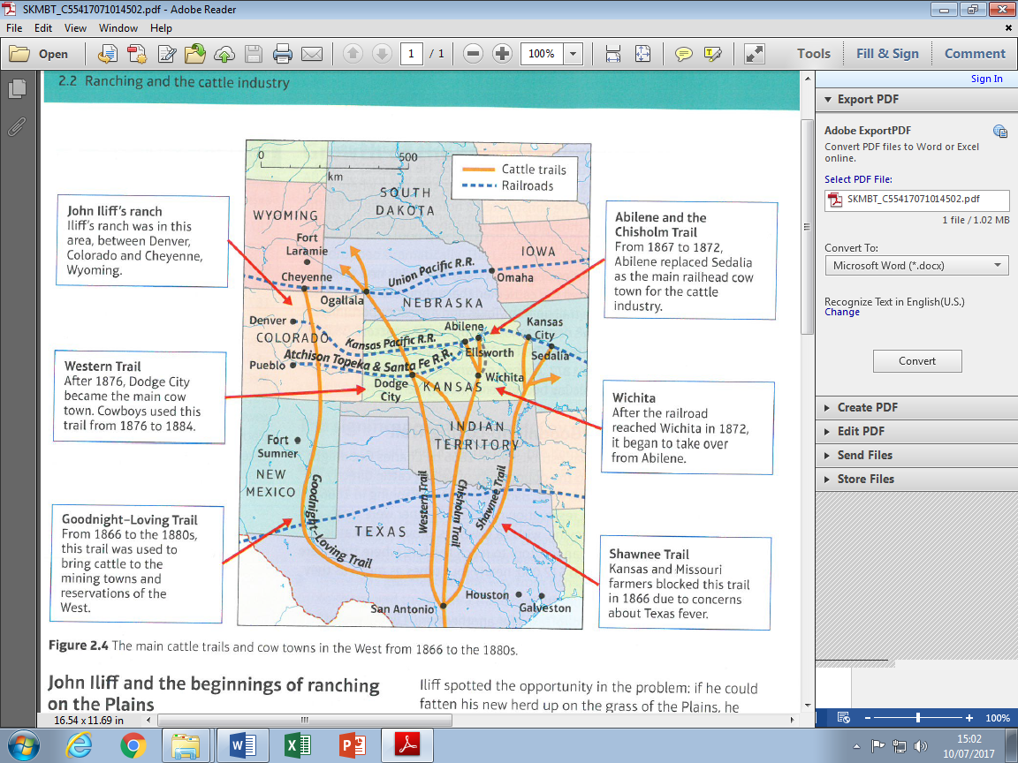
Cowboys and changes in the Cattle Industry
Driving cattle from Texas to Kansas up the Chisholm Trail took 2-3 months. Herding cattle up the Goodnight-Loving Trail to Cheyenne could take 6 months. Cattle could get spooked and stampede, they could get lost or injured, they had to be swum across rivers and transported safely across Indian Territory - this was really hard work for cowboys!!
Long Drives - 3,000 cattle about 12 Cowboys.
A trail boss was in charge and he got paid the most. There was a wrangler who cared for the horses. Cowboys changed horses 2 or 3 times a day to keep them fresh and prevent injuries. Cowboys slept in the open taking it in turns to keep watch. A chuck wagon followed the herd with food and medical supplies. Once at a cow town like Abilene cowboys herded the cattle into the stockyards and then onto railroad boxcars. After this was done they would get paid. Cowboys then used their wages to go into town and have a good time.
Life on the Ranch
Cattle in Texas were raised on ranches. Over the winter months most of the cattle roamed free and cowboys had to find another job. Those who were kept on would repair equipment and plan for the drives of the next year.
Real ranch work began in early spring with the round-up teams of cowboys fanned out across the range, found all the cattle and then drove them back to a central location. Then they were separated according to ownership which was decided by whose branding they had on them

Changes on the Plains
Ranches on the Plains carried out the spring round-up in the same way. A significant difference was winter on the Plains. If snow and ice was too deep it stopped cattle from feeding and drinking. So on the Plains cowboys had to go out in winter to ensure that the cattle had water to drink and could get to grass and feed. Some cowboys had to spend the winter in terribly lonely sod houses isolated and dotted across the open range so that they could watch over the cattle and ensure they were o.k.
Rivalry – Ranchers and Homesteaders
Ranchers needed large areas of land to graze their cattle and they could do this on public land on the Plains but Homesteaders could stake a claim to 160 acres that was their own land. So Ranchers did not want Homesteaders claiming land on the open range where they grazed their cattle. They used many tactics to stop this …
- They filed their own claims for the best bits of land with watering holes and springs.
- They got ranch-hands and cowboys to file claims and then give up the land to the ranch boss.
- Ranchers bought land from railroad companies and then fenced it off so that although it was mixed with public land nobody could access the public land.
- Rich ranchers took homesteaders to court and some threatened violence against homesteaders to warn them off their land.
When cattle roamed and ate crops and trampled on them farmers blamed ranchers for not fencing off the land, whereas ranchers blamed the farmers and said it was their responsibility to fence things off. Long-running disputes sometimes developed into conflicts.
Large-scale sheep herding started in the West in the 1870s and this created tension and conflict between ranchers and sheep herders who were competing for the same grazing land. Cattle barons often dominated local government and ensured that their interests were protected.
Conflict between settlers and Indians, railroads, cattle and gold …
The Fort Laramie Treaty of 1851 gave railroad surveyors and constructors permission to enter Indian lands. However the Plains Indians were unaware of the huge amounts of land that would be taken by the railroads and the consequent destruction of the buffalo and hunting grounds. The Pacific Railroad Act began to extinguish Plains Indian rights to land along the railroad routes. The route of the Northern Pacific Railroad ran through Dakota, Montana and Washington territories where tens of thousands of Plains Indians still lived and depended on buffalo hunting grounds.
Cattle and buffalo ate the same grass. In 1860 there were 130,000 cattle in the West all in Kansas and Nebraska. By 1880 there were 4.5 million cattle in the West - half of those were in Colorado, Wyoming, Montana and Dakota. As buffalo became hard to find some Indians had to work as cowboys for ranchers and became dependent on them for work, money and food. Indians like the Comanches resented cattle trails that trespassed on their land.
In California, gold prospectors had murdered Indians and forcibly moved tribes to get to the gold. The influx of miners from all over the world brought diseases that devastated the Indians. Gold mining changed the region so rapidly it had a massive impact on Native Americans. In 1862 gold was discovered in Montana and thousands of prospectors moved along the Bozeman Trail that ran through Lakota Sioux hunting grounds and was against the terms of the Fort Laramie Treaty.
Reservations and the Peace Policy of President Grant …
Indians were increasingly moved onto reservations and the U.S. government promised them they would be well looked after there with regular deliveries of food and supplies. However the government often did not keep their promises and some tribes resisted being pushed onto reservations. The Army was used to force Indians onto reservations.
The government though the reservations would help the Indians learn how to be farmers, teach them Christianity and how to read and write. HOWEVER, there were major problems with reservations …
- Reservations did not understand Indian culture - agreements were made with chiefs but they had no authority to keep bands on the reservations. Reservations were often a long way from sacred Indian heartlands.
- The challenges of farming on the Plains were even bigger for Indians because they had no experience and often the worst land. When crops failed the government had to give them food.
- The Bureau of Indian Affairs appointed agents to manage the reservations and they were often corrupt.
- White settlers wanted the land the Indians had and the government made any excuse to reduce the size of the reservations.
Policy makers in the East were worried about the slaughter of the Indians. They were especially concerned with the destruction visited on Native American women and children.
President Ulysses S. Grant, himself an author of total warfare when leading the Union armies, favoured a policy that would lead to citizenship for the Indians. The Board of Indian Commissioners set up in 1869 was supposed to stop the corruption of agents and improve conditions on the reservations they ran. Colonel Ely Parker, a Seneca Indian who had served Grant during the Civil War, was appointed to lead the Bureau of Indian Affairs as the President followed the impulse of humanitarians who wanted to civilise and assimilate Native Americans. Yet the problems of corruption that plagued his administration affected Indian affairs also. The “Indian ring” in the Department of the Interior stole funds and many on the reservations did not receive their welfare payments. In 1871 Parker was forced to resign in the midst of serious corruption allegations.
Poor conditions on the reservations meant that it was hard for the Indian agents to keep the tribes on the lands set aside for them. Furthermore the army found it hard to keep floods of white settlers out of the designated Indian territories. This all led to further violence as warfare in the West continued. The way the federal government dealt with the Indians began to change. An Indian Appropriations Act of 1871 stated that no new treaties should be made with Indian tribes. So existing treaties stood and Indians were treated as a tribal unit. Bilateral agreements and executive orders were used to conclude negotiations with the Indians and this had the effect of reinforcing tribal identities. This approach was opposed by white business interests such as railroad and mining companies. They thought the Indians had too much land and were not using it efficiently. Pressure was applied to the Bureau of Indian Affairs to break up the reservations and stop the road blocks to economic development. Christian reformers were motivated by paternalism in their desire to break up the tribes because they believed tribal identity was slowing down attempts to assimilate the Indians with white society.

Indian Wars
Little Crow’s War 1861 …
12,000 of the Santee Sioux lived on a Reservation in Southern Minnesota. In 1861 their corn crops were destroyed. They were therefore forced to live on government credit. In June 1862, government stopped credit at their store which meant the Indians could not get any food. Although Little Crow attempted to restrain his people violence broke out. Fighting continued from August-September 1862, during which time Little Crow attempted but failed to capture Fort Ridgeley. He was unable to persuade other Indian groups to join him. Over 700 settlers were killed which led to massive army reinforcements being sent in. Whilst Little Crow escaped other Santee Sioux surrendered. 38 Indians were executed and 2000 transferred to Crow Creek, during the first winter 400 of them died of cold and starvation.
The Sand Creek Massacre 1864 …
The Treaty of Fort Wise in 1861 was agreed by Black Kettle a Cheyenne Chief. This said that his people would move to a reservation in Colorado but many young warriors did not agree – they were called the Dog Soldiers. There were three years of conflict between these warriors and prospectors in Colorado.
Black Kettle agreed to meet the government for talks and set up camp at Sand Creek. However the governor of Colorado Territory appointed Civil War hero Colonel Chivington to kill the Indians.
On 29 November Chivington led 700 cavalry on a dawn raid that massacred 130 men, women and children who had put up a white flag of surrender. Black Kettle survived and took news of the massacre to other tribes. Warriors raided US forts and white settlers but during the Civil War the government could not commit lots of troops to the West to deal with this. A new treaty was agreed in 1865 that promised the Cheyenne and Arapaho a new reservation south of the Arkansas River and compensation to survivors of Sand Creek. After the Civil War the government pulled out of the deal, no compensation was paid and Black Kettle was killed in another massacre in 1868.
Red Cloud’s War 1866-68 …
In 1862 gold was discovered in the Rocky Mountains of Montana. New towns such as Virginia City sprang up along the Bozeman trail which closed Sioux land. This broke the First Fort Laramie Treaty which in turn led to Indian attacks. The government attempted peace talks with Red Cloud, but these broke down when the government ordered forts to be built along the Bozeman trail. Sioux attacks were random so that the army could not move safely outside the forts and no travellers could use the trail. The government were forced to admit defeat and therefore agreed to withdraw from the forts.
The Great Sioux Reservation was created and Red Cloud lived peacefully on the Reservation and his power passed to younger leaders such as Sitting Bull and Crazy Horse.
The Second Fort Laramie Treaty
The US government agreed to close the Bozeman Trail in return Red Cloud agreed to take his people to a reservation in Dakota. The second Fort Laramie Treaty recognised that this Great Sioux Reservation was to be for the exclusive use of the Sioux nation. But not all the Indians agreed with Red Cloud - Crazy Horse and Sitting Bull refused to sign.
Changes in farming
These changes in farming that had taken place by 1876 really started to have an impact in the period 1876-95. As a result of government policies and wider industrialisation of the USA the problems that faced Homesteaders in the West had become manageable by the 1890s. Homesteading was beginning to transform the Plains into a rich and fertile farmland.
Why was this?
- Dry farming - A technique pioneered by Hardy Webster Campbell in Dakota in 1879. This involved preparing the oil so that it trapped rainwater under the surface. It was particularly good for growing wheat.
- Wind pumps - Daniel Halladay developed a wind pump in 1854 that swung around automatically as the wind changed direction. The pumps helped to access water that was deep underground. By the 1880s, efficient, all-metal wind pumps that needed oiling only once a year had been developed. Strength and size increased to help access water very deep below the surface. So the biggest problem of farming on the Plains, access to water, was solved.
- In 1874 barbed wire was first introduced and this had a huge impact as it allowed farmers to fence off claims, protect crops and livestock.
- Mechanisation - Improved steel ploughs and seed drills that were drawn behind a horse and automatically planted seeds at the right depth made dry farming more successful. Mechanisation made farming faster and more efficient and it helped farmers become more successful and boosted the economy.
Changes in Cattle Industry …
So much money went into cattle ranching in the 1870s that the open range became overstocked. This had several serious consequences –
- Fall in demand in eastern states because beef was so plentiful meant decrease in prices paid for cattle.
- Soil erosion and loss of pasture land. When drought hit in 1883, the grass withered which made the problem worse.
- Winter of 1886-87 was known as the ‘Great Die Up’ with temperatures falling as low as -55 degrees Celsius. At least 15% of open range cattle died. The stock that did survive was in poor condition and everyone tried to sell what they had in the Spring of 1887 and this made prices fall even lower. These factors put an end to ranching on the open range.
Smaller Ranches became the model for the cattle industry after 1887 because …
- Smaller herds could be found more easily and brought close to the ranch for food and shelter.
- In times of drought it was easier to provide water to a small amount of cattle.
- Smaller herds were easier to guard.
- Smaller herds reduced the supply of beef and so increased prices.
- After 1887 ranchers moved to producing high-quality meat by breeding high quality cattle that were not allowed to roam on the open range and mix with other herds.
As ranchers went bankrupt or quit the homesteaders moved in and this often led to conflict as homesteaders fenced off land that ranchers wanted to use.
What was the impact of the end of the Open Range?
The end of the open range meant there was a lot less demand for cowboys, those that remained in the cattle industry were employed as ranch hands.
They had less adventurous lives, mending barbed wire fences, inspecting grass, looking after horses etc …; they lived in bunkhouses that were often not very comfortable and let water in and had beds full of lice; they were responsible for ‘riding the line’ patrolling the boundary between one ranch and another; ranches did join together for the yearly round-ups where cowboys rode out on the range searching for stray cattle.
THE Exoduster Movement
The ideas of Manifest Destiny were inherently racist as white settlement involved inhuman treatment of Native Americans. Racism was a constant reality in American society and the freed slaves of the southern states that had lost the Civil War were subject to segregation and discrimination.
EXODUS - because there was oppression of black Americans in the South many decided to move west and take up Homestead Act claims to own land. A former slave Benjamin Singleton pioneered the move to Kansas. He set up a settlement in 1873 and promoted migration to Kansas. He created the foundations for an extraordinary, large-scale migration of black Americans to Kansas in 1879. There was a rumour among ex-slaves that the government had given land for thousands of black Americans to settle in Kansas. This was not true but by the end of 1879 40,000 had set off West heading for Kansas, Missouri, Indiana and Illinois.
Black settlers were called the EXODUSTERS - an exodus to the dry and dusty West.
Singleton was not the only reason for the migration. Other factors included –
- Henry Adams who promoted the idea of black emigration – there was widespread interest in a back to Africa plan including to Liberia, a new state.
- Many blacks were also moving within the South looking for better jobs and opportunities.
- Kansas had a historic reputation as an anti-slavery state.
- The Homestead Act offered the promise of free land.
- The Biblical story of the Exodus provided a religious push factor and inspiration.
Impacts of the Exoduster Movement
- By 1880 there were 43,107 blacks in Kansas settling 81 square km of land.
- Many blacks came thinking the land was free and needed charity and help to survive. The best land had already been taken by whites.
- The Kansas government helped those who had travelled through areas affected by yellow fever and so became ill. The governor set up an association to help the migrants.
- White settlers in Kansas were against the Exodusters and thought they should be sent back to the South.
- The reality in Kansas filtered back to blacks in the South and the migration slowed in the 1880s. Exodusters were usually poorer than whites and after the 1880s many moved further west into Nebraska and then Oklahoma.
Oklahoma Land Rush
Indian Territory had been set aside as part of the Indian Removal Act. In 1889 the government decided to open up the middle section of Indian Territory for white settlement. The land was divided up by government surveyors into 160-acre sections, and it was announced that at noon on 22nd April 1889, the area would be opened for claims. Once a signal was given thousands rushed onto the land to stake their claim. This was the land rush.
There were 7 land rushes in Oklahoma from 1889 to 1895. The largest was when 8 million acres were opened up for settlement. These land rushes and pressure from whites to get more land reduced further and further the amount of land for Indians.
Law and Order (continued) …
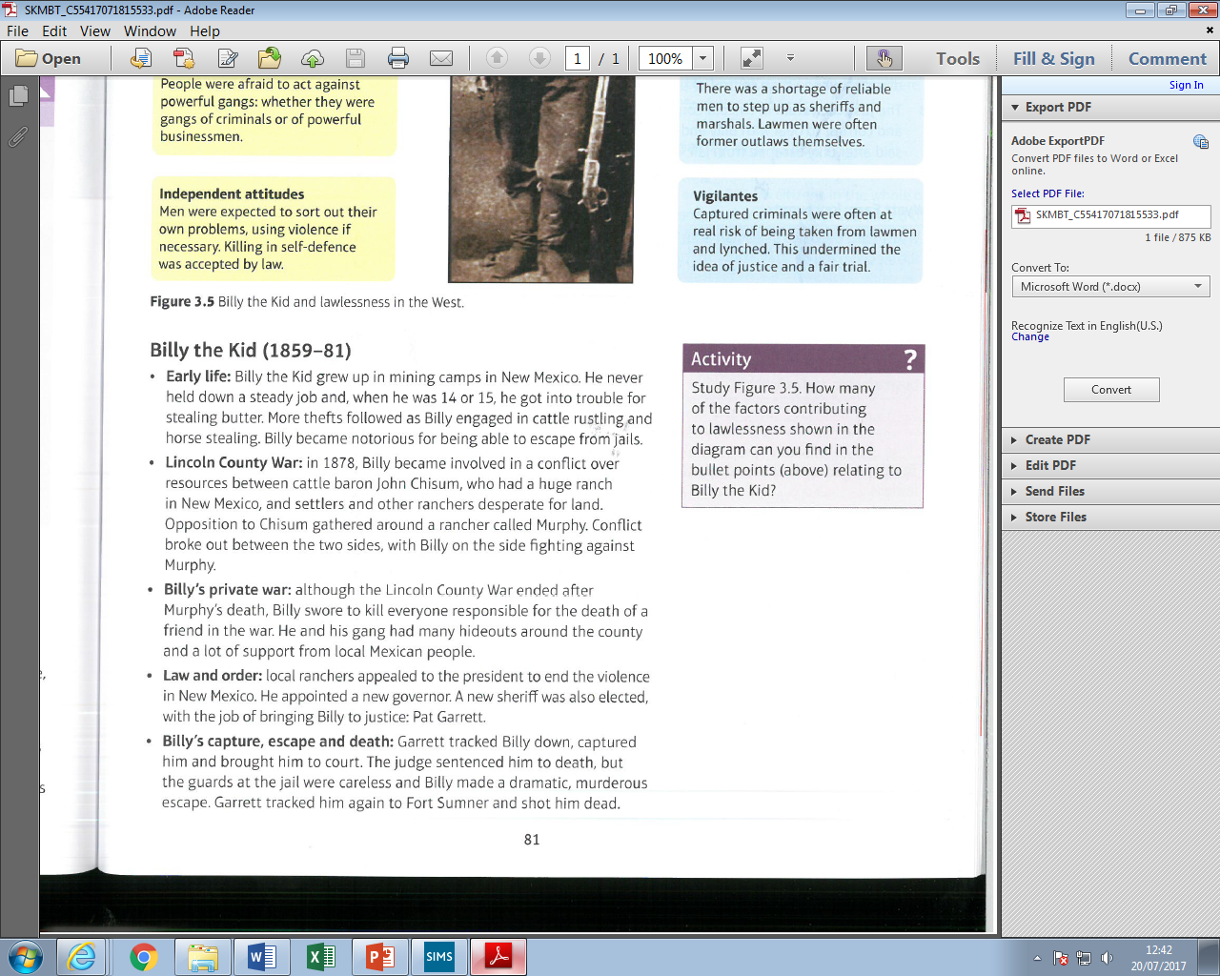
Although Billy the Kid was a thief and a murderer he was seen as exciting, reckless and romantic and this view was fuelled by newspapers and cheap novels.
He was important because …
- Powerless people liked the way he stood up against big northern businessmen who were dividing up America for themselves.
- Most of his involvement in violence was as a hired gun in conflicts between cattle barons and those who challenged them.
- The justice system in Lincoln County was too weak to deal with Billy and his gang.
Wyatt Earp and the OK Corral 1881
Northern businessmen who came to cow towns to make money did not appreciate the violence and lawlessness of cowboys there. They hired sheriffs and marshals to protect the towns and enforce the law. They selected men like Wyatt Earp who had the tough personality for the job.
In general lawlessness decreased as settlements developed. People needed their businesses and property to be secure so they voted in town governments that banned guns. When frontier towns were connected to big cities by rail and telegraph it meant that back up could be sent for. So consequently the violence of men like Billy the Kid and Wyatt Earp was the exception not the rule.



The Range war and Johnson County War
In 1870 there were only 9,000 citizens in the whole of the Wyoming Territory. Throughout the 1870s huge cattle ranches developed. Big ranchers became powerful but after the severe winter of 1886-7 this power decreased. Small ranchers did better but big ranchers accused them of stealing or rustling cows. So they set up the Wyoming Stock Gowers Association (WSGA) to ban small ranchers they suspected of rustling. But juries made up or ordinary people resented the power of the big ranchers and almost never convicted anyone of rustling. Big ranchers took matters into their own hands.
Ella Watson and Jim Averill farmed a homestead in the middle of cattleman Albert Bothwell’s open-range pasture area. They were there legally but he wanted them gone. Jim averill wrote a letter to a local newspaper accusing cattlemen of being rich land grabbers and Ella Watson bought a small herd but was accused of rustling. Bothwell and his men kidnapped Ella and Jim and then hanged them. Other killings took place with small ranchers targeted. In 1892 the homesteaders and small ranchers set up their own organisation. They held their own round-up a month before the WSGA so they could claim all the unbranded cattle.
The WSGA planned a full-scale invasion of Johnson County to kill 70 men. This plan was made with the full knowledge of the Wyoming Governor. The WSGA raised $100,000 and hired 22 Texas gunmen who were promised a $50 bonus for every rustler they killed. They were brought into Wyoming on a train specially supplied by the Union Pacific Railroad Company.
The hit-men deviated from their plan and went to the KC Ranch where two men on their list, Nate Champion and Nick Ray, were. Nate held them off all day before being killed. Word reached the Sheriff of Johnson County who raised a force of 40 men to go after the invaders from Texas. The invaders dug it in at the TA ranch but were surrounded by 300 angry Johnson County residents before the US cavalry turned up.
The invaders had powerful friends including the state governor, the judge and two US Senators. The invaders were taken to Fort Fetterman on the orders of the governor in case they were lynched. The WSGA hired the best Chicago lawyers to defend the men. The lawyers convinced that passions ran too high for the men to receive a fair trial in Johnson County so the trial was moved to the state capital, Cheyenne. The lawyers extended the case for long enough for the prosecution to run out of money and the charges against the accused had to be dropped.

Conflict with the Plains Indians
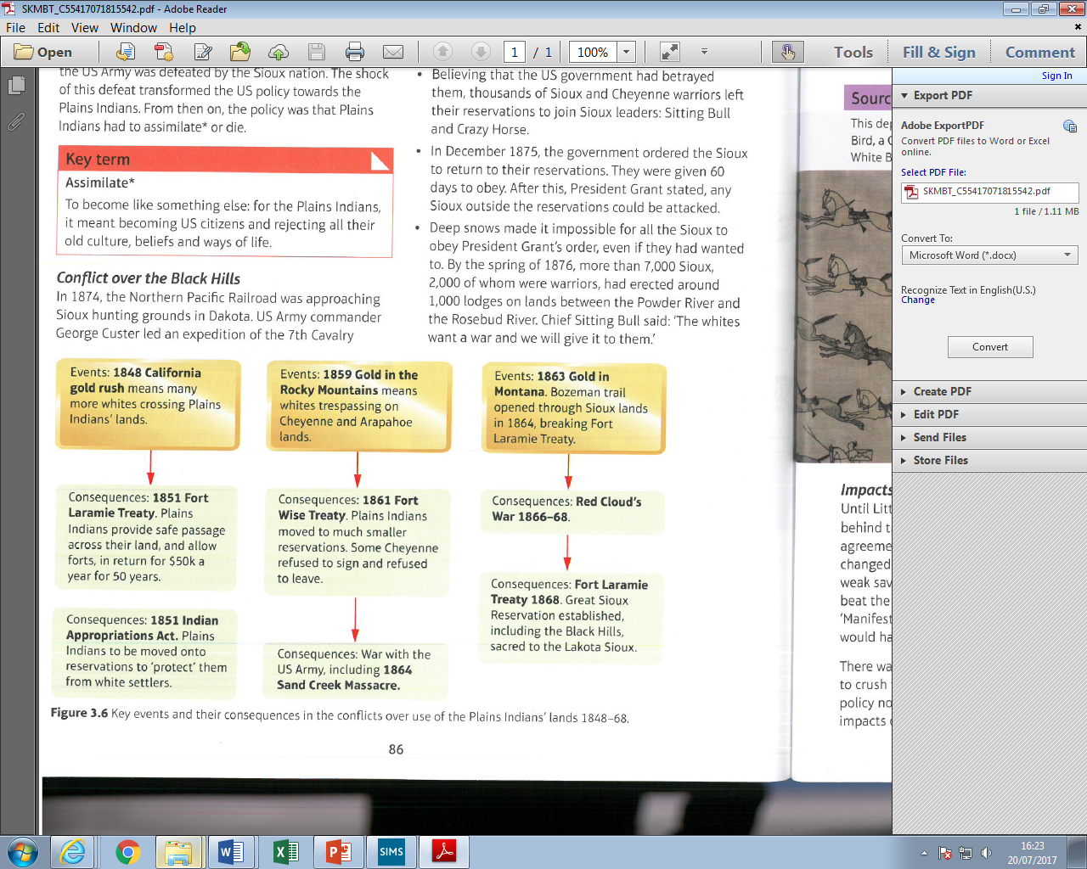

The Great Sioux War and the Battle of Little Bighorn
The Battle of Little Big Horn in 1876 was a turning point in the history of the American West. After the Sioux nation defeated the US Army in this engagement policy makers decided that Plains Indians now had to assimilate or die.
In 1874 the 7th cavalry led by George Armstrong Custer was sent into the Black Hills to both protect the railway surveyors and check for gold. This broke the Fort Laramie Treaty of 1868. The government offered $6 million to buy the Black Hills, but the Indians refused and relations with them broke down. In December 1875 all Indians were ordered onto the reservations. Under the leadership of Sitting Bull and Crazy Horse 7000 refused, and the government declared them hostile, so began a campaign which eventually led to the Battle of Little Bighorn.
In 1876 the U.S. army was ordered to attack all Sioux who were not on the reservations. General Sheridan was the officer in overall command and drew up a plan for three columns of troops to converge on the Indians and trap them. Yet the communication between the different groups of men was poor and they were unaware of how many Indians they were about to attack. On June 17th Crazy Horse led a full attack on one of Sheridan’s columns under General Creek and forced them to retreat. The Sioux warrior took his braves to join up with Sitting Bull on the Little Bighorn. Custer was given orders to approach the Indian camp and was offered extra men but refused.
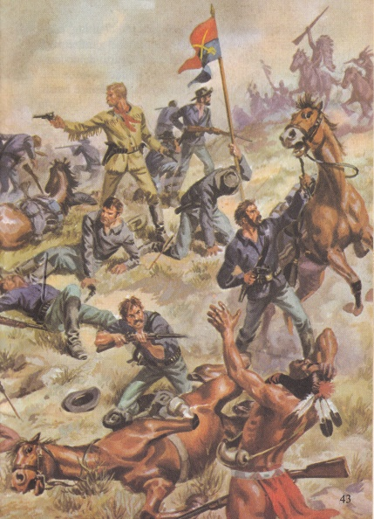
The impetuous Custer ignored orders and drove his men on a gruelling march and got to the Little Bighorn a day early. Sitting Bull and Crazy Horse were not expecting an attack but Custer’s men and horses were tired. Ignoring advice from his Indian scouts Custer decided to attack. He had only 600 men and was about to advance on approximately 2,000 warriors. Even so, he divided his forces and led a group of soldiers himself to attack the Sioux camp on the Little Bighorn.
His other troops under Major Reno and Captain Benteen were pushed back by Indian attacks and were never able to reinforce Custer. He and his men were surrounded by Crazy Horse and 266 soldiers were cut down. At 4p.m. on June 25th Custer made his famous “last stand.” Crazy Horse and his braves had won the battle but victory in the war for the Plains was already beyond them. A Crow scout named Curley had disguised himself as a Sioux warrior during the carnage and survived to bring news of the defeat of the seventh cavalry to officials in the East.

Impact of the Battle of Little Big Horn
The defeat of Custer and his men shocked people back in the East. There was now enormous pressure on the government to crush the remaining Indian resistance. Government policy now focused on this …
- The army pursued the Sioux and Cheyenne and forced them back onto reservations. By the early 1880s these tribes had drifted back to the reservations and were totally dependent on the government.
- Previous treaties were now ignored. The Sioux were told to give up the Black Hills or the government would stop giving them food and essentially starve them to death.
- The Sioux’s weapons and horses were taken from them and the numbers of soldiers in forts in the region were increased.
- In 1877 Crazy Horse surrendered to the US Army, he was killed at Fort Robinson whilst under arrest.
The Wounded Knee Massacre 1890
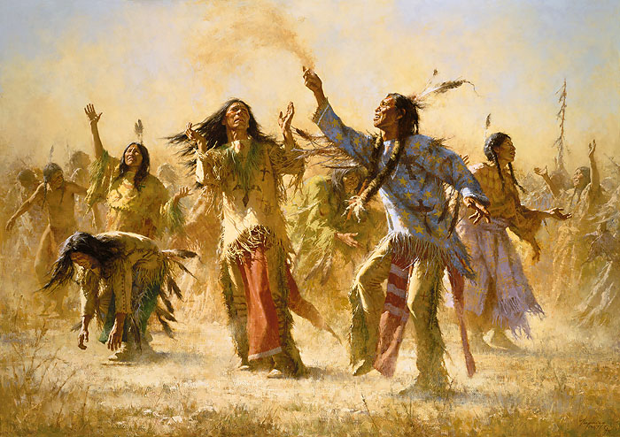
The Indians on the reservations were trapped in idleness. Consumed by defeatism and disillusionment they turned to dreamers and medicine men for comfort. Wavoka of the Mason Valley Paiutes said the Great Spirit wanted the Indians to dance. The Great Spirit would then sweep across the prairies of the West and destroy the whites before bringing back the glory days. The buffalo and all the fallen warriors would return and restore the old way of Indian life. The Indians should dance and resist the ways of the wicked white man.
This was the “ghost dance” to summon up the spirits of the past. The first ghost dance was performed on the Walker Lane reservation in Nevada in January 1889. It was a simple ceremony of dancing in a circle which contracted and widened again and again. The dancing lasted for a day and a half with Wovoka in the middle of the circle sitting by a large fire.
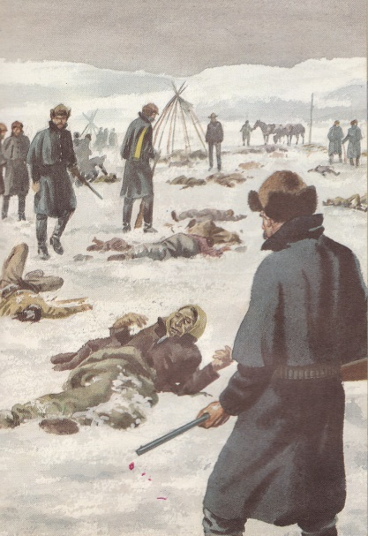
Within weeks many tribes of the Rocky Mountains were dancing the Ghost Dance. Then the Sioux of the Dakotas converted to the religion. In the spring of 1890 the Sioux began dancing the ghost dance at Pine Ridge. They added new symbols and wore ghost shirts made of cotton cloth and painted blue around the neck. They sang, “The whole world is coming. A nation is coming, a nation is coming. The eagle has brought the message to the tribe. The father says so, the father says so.” The chants became warlike and Sitting Bull joined the ghost dance cult. The white authorities feared that the ghost dance was getting out of hand and moved to arrest Sitting Bull on December 15th 1890. His men resisted the attempt to arrest their leader and in the struggle that followed Sitting Bull was shot in the head and killed.
His followers fled the reservation and headed west to join up with an old chief named Big Foot. He intended to lead his people to the Bad Lands beyond the reservation. Major Whitside of the seventh cavalry moved to intercept the Indians and told Big Foot to lead his people to Wounded Knee Creek and make camp. The Indians wore their ghost dance shirts as they marched towards the creek. They thought these shirts made them immune to the white man’s bullets. They were convinced that the Great Spirit was going to bring the return of their old lands and the buffalo of their hunting grounds. In total, 170 men and 230 women and children were told where to camp and given rations when they arrived at Wounded Knee. The next morning the medicine man led a ghost dance. It seemed to the white soldiers that trouble was coming. When the Indians raised their weapons above their heads the soldiers opened fire.
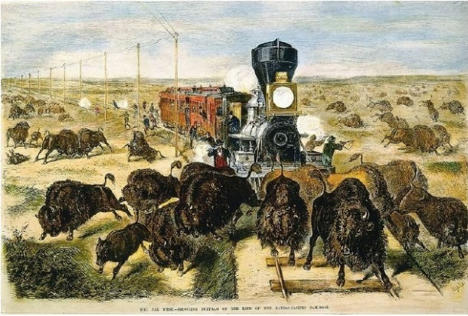
A Hotchkiss gun was pointed at the camp and mowed the Indians down. Within a few minutes 200 Indian men, women and children and sixty soldiers lay dead and dying. Big Foot was found by the burial party frozen in the winter snows, his body twisted as it was when he had fallen. The wounded Sioux were taken to Pine Ridge where they were housed in an Episcopal mission. It was 29th December 1890 and Dee Brown evocatively described the scene in his Indian history of the West entitled Bury My Heart at Wounded Knee. “Torn and bleeding bodies were carried into the candlelit church…Across the chancel front above the pulpit was strung a crudely lettered banner: ‘Peace on earth, good will to men.’”
In 1890 the US government declared that the Indian Frontier had ended - all resistance was dead.
Hunting and Extermination of the Buffalo
By 1883 the once vast herds of buffalo (25 million or more) had gone. The government chose to support the extermination of the buffalo because –
- Before 1871 buffalo had been killed for their fur for warm coats but in 1871 a cheap process of turning buffalo hide into leather belts was discovered so people rushed to slaughter as many buffalo as possible.
- Railroads brought hunters to the Plains and then transported the hides back east.
Extermination North and South
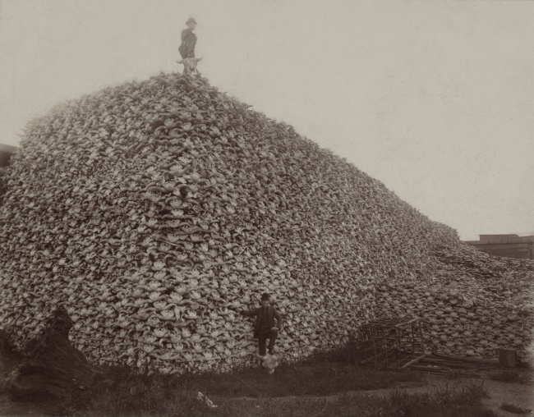
- 1872-74 so the peak in the killing of the southern herds when professional buffalo hunters killed 4 to 4.5 million.
- The northern herd was protected by the Great Sioux Reservation until 1876. But when this land was broken up the Northern Pacific Railroad also reached Sioux land.
- By 1880 an estimated 5,000 whites were killing and skinning the buffalo. By 1883 the northern herd had gone.
Extermination and Government Policy
The policy of extermination supported the government’s aim of moving Indians onto reservations …
- If there were no buffalo herds to follow Indians would be forced to live in fixed areas.
- Treaties allowing Indians to hunt out of the reservations had clauses that said this was only the case as long as there actually were any buffalo to hunt.
- Without their main source of food Plains Indians had to learn to farm and be more like white people.
- Without their main food source the Indians were at the mercy of the government who could force them to do something by threatening to stop sending them food.
- Areas without buffalo made for easier railroad construction.
- Extinction of the buffalo meant more room for cattle ranching.
The impact of buffalo extinction shattered the Indian way of life. They were often given the worst land to farm and crops failed. On the reservations they were dependent on the government and often malnourished which reduced their resistance to diseases. Many died from flu and measles for example.
Life on the Reservations
By the 1880s white opinion was that allowing Indians large reservations was wrong, it was not helping them to assimilate to be more like white people. In breach of the Fort Laramie Treaty of 1868 Plains Indians were forced to accept a reduction in the size of their reservations. The US government set up special councils to undermine the power of tribal chiefs and used bribes and threats to get them to agree changes to the size of reservations. In 1883 special courts took away the power of Chiefs to judge and punish Indians. By 1885 Plains Indians were under US federal courts and so had lost all ability to govern themselves.
A number of Plains Indians joined the Indian Agency Police and were given extra food and shelter to help keep the Indians in order on the reservations. Indian children were sent to boarding schools like the Carlisle Indian School in Pennsylvania. Here they were taught to be like white children. By 1887 over 2,000 children were at 117 schools with the aim ‘to kill the Indian but save the man.’
The whole economic basis of Indian lives was undermined with the killing of the buffalo. A nomadic hunting existence was gone and there was an expectation that farming would be the new way of life. Dependence on the government robbed Indians of their pride and self-respect.
Changing Government Attitudes
By the late 1880s government policy was increasingly influenced by eastern Christian reformers who wanted to civilise and assimilate the Indians. To many would-be settlers it did not seem right that Indians had large areas of land that they were not using ‘properly.’
These two views combined to convince the government that the reservations were the problem. They took up too much land and they also actually stopped Indians from becoming more like white farmers. Indians on the reservations were dependent on the government and were not motivated to start their own farms.

Dawes Act, 1887 …
This was like the Homestead Act for Indians. Each Indian family was allotted a 160-acre share of reservation land. Single Indians were allotted 80 acres and orphans under 18 got 40 acres. Plains Indians who took the offer of the land could eventually become citizens. All the reservation land left over could be sold to whites.
The Dawes Act aimed to …
- Break up the power of tribes and chiefs.
- Encourage individual families to farm for themselves.
- Encourage Indians to assimilate and become citizens.
- Free up more land for settlers.
- Reduce the cost to the government of running the reservations.
The Dawes act succeeded in freeing up more land for white settlers as Indians lost half of the land they had still possessed in 1887. However, it failed to turn Indians into citizen farmers. Allotment did not start straight away, when it did Indians resisted by putting their plots next to others in the tribe to try and keep a sense of tribal community. Those who took up allotment found the land tough to farm and when they passed it on to their children it was divided up into smaller plots which made it even harder to farm.

Life for Plains Indians became even harder in conditions that were even worse.

American West Exam Questions
Consequence Question: 8 marks (4 marks each)
1) Explain two consequences of the setting up of the Oregon Trial (1836).
2) Explain two consequences of the Fort Laramie Treaty (1851).
3) Explain two consequences of the Homestead Act (1862).
4) Explain two consequences of the development of ranching on the Plains in the years 1866-76.
5) Explain two consequences of the opening of the Transcontinental Railroad (1869).
6) Explain two consequences of the winter of 1886 - 87 for the cattle industry.
7) Explain two consequences of the Battle of Little Bighorn (1876).
8) Explain two consequences of the introduction of barbed wire in the West (1874).
9) Explain two consequences of the American victory in the Mexican-American War.
10) Explain two consequences of the discovery of gold in California in 1848.
11) Explain two consequences of the ending of the Civil War in 1865 for the settlement of the West.
12) Explain two consequences of the discovery in 1871 in an eastern tannery of a process to make high quality leather from buffalo hides.
13) Explain two consequences of the second Fort Laramie Treaty (1868).
14) Explain two consequences of the discovery of gold in the Rocky Mountains around Virginia City in 1862.
15) Explain two consequences of the Johnson County War in 1892.
16) Explain two consequences of the defeat of the Seventh Cavalry at the Battle of Little Bighorn.
Narrative Account: 8 marks
1) Write a narrative account analysing the ways in which the US government policy towards the Plains Indians developed in the period 1835 – 51.
You may use the following in your answer:
* Permanent Indian Frontier (c1834) * Indian Appropriations Act (1851)
You must also use information of your own.
2) Write a narrative account analysing the key stages in the growth of cattle ranching in the years 1861-72.
You may use the following in your answer:
* Joseph McCoy & Abilene * cattle barons
You must also use information of your own.
3) Write a narrative account analysing the events of the Indian Wars, 1862 - 1868.
You may use the following in your answer:
* Little Crow’s War (1862) * Second Fort Laramie Treaty (1868)
You must also use information of your own.
4) Write a narrative account analysing the ways in which settlement in the West developed in the years 1876 - 1895.
You may use the following in your answer:
* the Exoduster movement (1879) * the Oklahoma Land Rush (1893)
You must also use information of your own.
5) Write a narrative account analysing the conflict between the Plains Indians and the US government in the years 1876 - 1890.
You may use the following in your answer:
* the Battle of Little Bighorn (c1876) * the Ghost Dance (1890)
You must also use information of your own.
6) Write a narrative account analysing the key events that led to the beginning of Red Cloud’s War in the years 1851 - 1866.
You may use the following in your answer:
* Fort Laramie Treaty (c1851) * the discovery of gold in Montana
You must also use information of your own.
7) Write a narrative account analysing the main developments in US government policy towards the Plains Indians in the period 1836 - 1861.
You may use the following in your answer:
* the movement of the Bureau of Indian Affairs * Fort Laramie Treaty (c1851)
You must also use information of your own.
8) Write a narrative account analysing why Americans went West in the years 1836 – 1849.
You may use the following in your answer:
* the Oregon Trail from 1836 * the California Gold Rush 1849
You must also use information of your own.
9) Write a narrative account analysing the development of the railroads in the years 1860 - 1975.
You may use the following in your answer:
* the Railroad Act 1862 * the use of Chinese labour
You must also use information of your own.
10) Write a narrative account analysing the ways in which homesteaders solved the problems of farming on the Great Plains in the years 1862 – 1876.
You may use the following in your answer:
* the development of the railroads * the invention of barbed wire
You must also use information of your own.

Importance Question: 16 marks (8 marks each)
1) Explain the importance of the Oregon Trail for the early settlement of the West.
2) Explain the importance of the Indian Appropriations Act (1851) for the way of life of the Plains Indians.
3) Explain the importance of the development of new mining towns for law and order in the early West.
4) Explain the importance of the discovery of gold in California (1848) for the settlement of the American West.
5) Explain the importance of cattle trails for the development of the cattle industry in the 1860s.
6) Explain the importance of the Battle of Little Bighorn (1876) for government attitudes towards the Plains Indians.
7) Explain the importance of the Johnson County War (1892) for law and order in the West.
8) Explain the importance of the Oklahoma Land Rush of 1893 for the settlement of the West.
9) Explain the importance of railroads for changes in the way of life of the Plains Indians.
10) Explain the importance of the wagon trails for the early settlement of the West.
11) Explain the importance of the buffalo to the Plains Indians way of life.
12) Explain the importance of warrior societies to the Plains Indians way of life.
13) Explain the importance of horses to the way of life and means of survival of the Plains Indians.
14) Explain the importance of religion to the way of life of the Plains Indians.
15) Explain the importance of the Indian Appropriations Act 1851 to the way of life of the Plains Indians.
16) Explain the importance of the leadership of Brigham Young to the successful settlement of the Great Salt Lake by the Mormons.
17) Explain the importance of the rapid growth of mining settlements for government efforts to bring law and order to the West.
18) Explain the importance of the Homestead Act 1862 for the settlement of the West.
19) Explain the importance of Joseph McCoy to the development of the cattle industry.
20) Explain the importance of cowboys for the cattle industry.
21) Explain the importance of the strategy of total war for the US army’s defeat of the Plains Indians.
22) Explain the importance of the Dawes Act (1887) for the way of life of the Plains Indians.

