**Revision - Spanish**

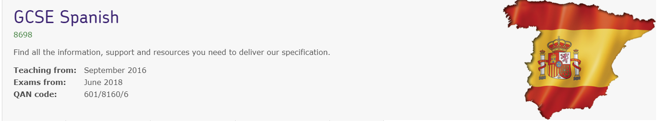

Specification link;

[AQA | GCSE | Spanish | Specification at a glance](https://www.aqa.org.uk/subjects/languages/gcse/spanish-8698/specification-at-a-glance)

Spanish Revision Guide:

[GCSE (padlet.com)](https://padlet.com/senoritadiaz/gcse-ur7j9qiz9tsu18ko)