Edexcel History

**Whitechapel, c1870-1900: Crime, policing and the inner city**

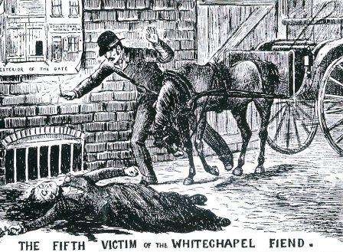

Revision Guide

How to answer questions in the exam:

**Q.1 4 Mark question:**

Spend 5 minutes on this question and make sure you **identify two features** with **supporting information**.

Example question and answer:

1. ***Identify and describe two features*** *of working conditions in Whitechapel in the late 1800s and give one piece of supporting information for each (in red) to get full marks:*

*Many residents worked in cramped and dusty sweatshops. (1) These included trades like match making, tailoring or shoemaking. (1)*

*Others worked on the railways or as labourers in the London docks. (1) The amount of work offered varied day to day though. (1)*

**Q.2 - 8 Mark *‘How useful are two sources for an Enquiry’* Question**

Spend 15 minutes on this question.

*How useful are sources A and B for an enquiry into an aspect of life in Whitechapel? - Explain how the information in* ***EACH*** *source is* ***USEFUL*** *for the enquiry, quoting/referring to the actual information;* ***PURPOSE:*** *explain why the source was produced (what information are you given in the description of the source?);* ***RELIABILITY****: say what it is about the source(s) that mean that you can trust the information it/they provide(s);* ***LIMITATIONS****: using your knowledge of the situation, events and investigations in Whitechapel during this period what valuable information is missing from the two sources?*

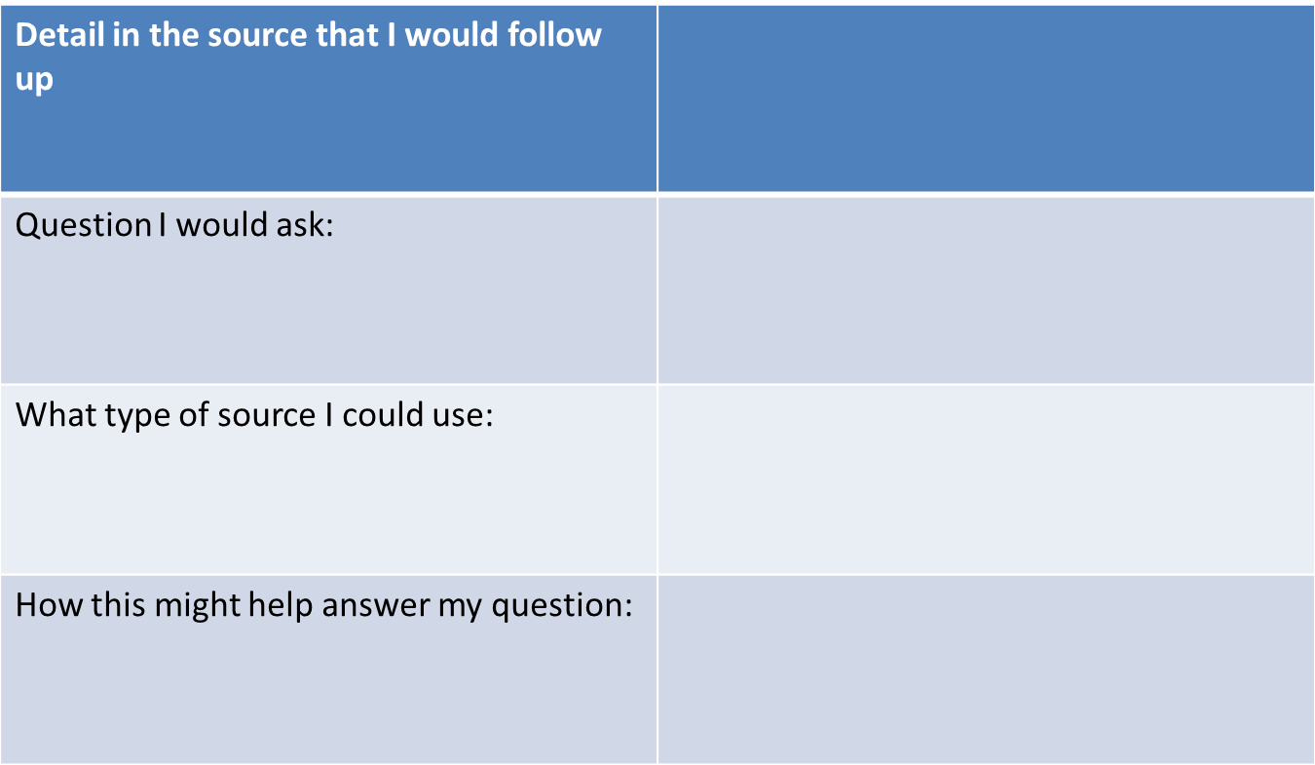 **Q.3** – **4 mark question**

*For this question you will be asked how you would follow up Source A to find out more about the enquiry:*

Types of source you can use to follow up:

*Police reports: H Division;*

*Government reports*

*Court records: Old Bailey; Memoirs/Diaries: inspector Abberline, Sir Charles Warren*

*Newspapers: ‘Penny Dreadfuls’, Official statistics: census data*

What was it like to live in Whitechapel 1870-1900?

Pollution and housing:

London in the 1800s was a heavily polluted, industrial city. The prevailing wind carried gas fumes and smoke towards the East end. At times it was not possible to see your hand in front of your face. Sanitation was also poor and there was very little drinking water. Sewers ran into the street. The majority of housing was overcrowded slum areas – known as ‘rookeries’. These were characterised by dirt, disease and crime. Houses were divided into several apartments and there could be up to 30 people in one apartment, sharing beds so densely packed together that it was difficult to move about.

In 1877, one rookery contained 123 rooms, with accommodation for 757 people, where families hovered on the brink of starvation. The 1881 census shows there were 30,709 people but only 4,069 occupied houses. Accomodation was also offered in lodging houses that offered little more than a bed in squalid conditions. Some lodging houses had eight three hour sleeping shifts a day, so beds could be used by the maximum number of people. The smell and the heat in summer, coupled with the presence of rats, meant this form of accomodation was truly awful. It is estimated that there were 200 lodging houses at this time in Whitechapel housing 8,000 people.

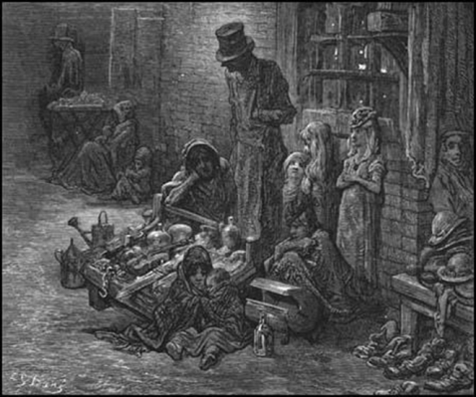 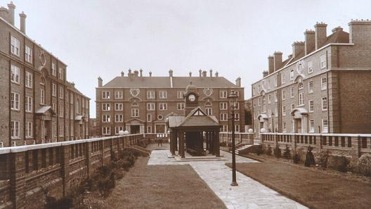

***The Peabody Estate***

Model Housing: The Peabody Estate

Whitechapel housing wasn’t all bad. In 1875, parliament passed the Artisans’ Dwellings Act as part of London’s earliest slum clearance programmes. A maze of narrow courtyards filled with cramped and unhealthy houses was replaced with 11 new blocks of flats. These were designed by Henry Darbishire and paid for by George Peabody, a wealthy American who moved to London. The Peabody estate opened in 1881 and provided 286 flats. Weekly rents started at a reasonable three shillings (15p) for a one room flat and went up to six shillings for three rooms. The average working wage for a labourer at this time was 22 shillings and 6 pence (£1.12) and some poor working-class families spent as much as a third of this on rent.

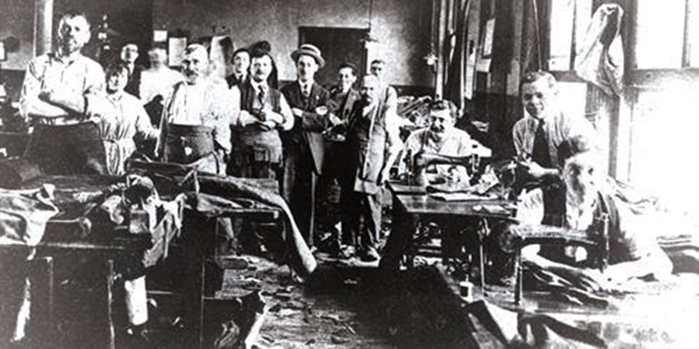Work in Whitechapel

Whitechapel’s most famous factory was the Bell Foundry, where Big Ben was cast. However, many residents worked in ‘sweated’ trades like tailoring, shoemaking or making matches. The work premises – known as sweat shops – were small, cramped and dusty, with natural light. Hours were long (some sweat shop workers worked 20 hours a day and slept on site) and wages were low.

Workhouses and orphanages:

Workhouses had been set up earlier in the 19th century as part of the poor relief system and were run by Poor Law administrators. They offered food and shelter to those too poor to survive in the community. Inmates of workhouses included the sick, old, disabled, orphans and unmarried mothers. Conditions were deliberately made worse than those that could be provided by a labourer for his family. The aim was to keep the costs down by putting poor people off from entering the workhouse – except as a last resort. Inmates were expected to do tough manual labour and wear a uniform. Families were split up and could be punished for trying to talk to each other. Vagrants, who stayed just a few nights were held separately from long term residents, as they were thought to be lazy and a bad influence on the others.

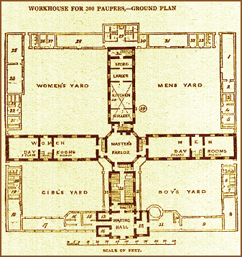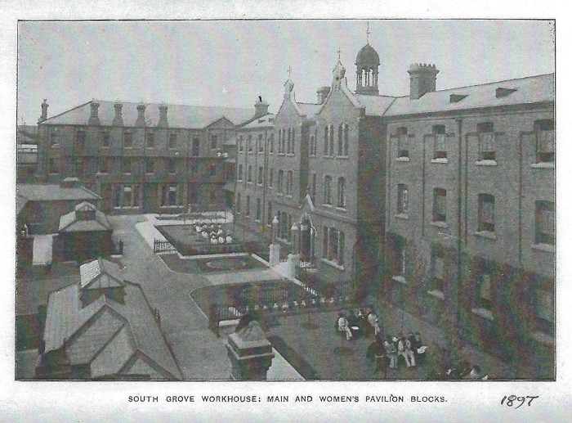

Why did immigration cause tensions in Whitechapel in the 1800s?

Irish immigration to Whitechapel

The Irish population expanded rapidly in the East End from the 1840s. The first immigrants were young men who came to London with plans to move to America, but ran out of money before they could find a ship to take them there. The Irish settled into areas near the river and made their living as ‘navigators’ or ‘navvies’ who did labouring jobs on canals, roads and railways, or as dockers on the River Thames. Violence amongst the Irish was commonplace, especially when drunk. As a result, they were not well liked by some in the Whitechapel area.

Fenians

In the mid and late 19th century Irish Nationalists were demanding freedom from rule by the UK. The fight was led by Fenians, a mainly Catholic group, who were seen as a fanatical, religious terrorist movement. Fenians organised a bomb attack on Clerkenwell prison, in December 1867, and there was a huge surge in anti-Irish feeling. A new department of the Metropolitan police, known as special branch, was formed to counter Irish terrorism. Terrorist attacks by Fenians made life harder for Irish immigrants as in the press and popular imagination, they were seen as probable Fenians and potential traitors. On a single day, 24 January 1885 (known as Dynamite Saturday), the Fenians launched almost simultaneous attacks on London Bridge, the House of Commons and the Tower of London and further causing tension in Whitechapel.

Eastern European Jewish immigration

Many Jews came to Whitechapel from Russia, Poland and Germany as they faced a wave of violence and abuse in those countries. By 1888, the Jewish population of parts of Whitechapel had grown to 95% of the total as Jewish settlers became small communities. The Jewish settlers were widely resented by the local population and this based around cultural differences and conflicting attitudes to work. Compared to poor, working class locals in Whitechapel, foreign Jewish workers seemed quick to find employment or set up businesses. The locals resented their success. Some established Jewish immigrants preferred employing newer arrivals to locals and new arrivals would accept lower wages. Many Jewish immigrants ran tailoring businesses on the sweatshop model. Businesses that followed government rules about fair working conditions couldn’t compete with the prices charged by the sweatshop owners.. Local shopkeepers suspected Jewish demands for Sunday trading were an attempt to drive them out of business. Religious and cultural rules about food and clothing made the new immigrants stand out and locals were suspicious of the unfamiliar customs and languages.

Anarchists:

From the middle of the 19th Century, social and economic problems across Europe caused the growth of revolutionary political movements that thought the answer was to overthrow existing governments. Anarchy was a political movement that opposed all forms of organised government. In 1871, Anarchists and other revolutionaries briefly took control of Paris, but most attempts at revolution failed. When this happened, the leaders fled and often headed for Britain. Britain was seen as a politically tolerant country. Some began to feel that East London had become a refuge for other nations’ terrorists. In 1893, Special Branch began an undercover operation to monitor the activities of Eastern European revolutionaries and anyone with an Eastern European accent was suspected of terrorism. However, the number of bombings and outrages supposedly committed by Anarchists in Europe was greatly exaggerated.

Socialists:

Another potentially revolutionary group were the socialists. Socialists are those who believe poor people would get a better deal if the government took over industries and services and ran them for the good of all (not for profit). Socialist leaders (known as radicals) wanted a revolution to bring down the existing capitalist system (a system where individuals are free to own businesses or property and can make a profit). The Social Democratic Federation (SDF) was founded in Britain in 1881. It was the first Socialist party in this country and represented farm workers, industrial labourers and the rights of women. The SDF was involved in the Trafalgar Square demonstration of 1887 that led to bloody Sunday ( a protest that was dealt with harshly by the Met Police). They saw the police as the public face of a government that did not care for downtrodden people at a time of economic depression. In the autumn of 1888, campaigning began for the first ever elections to the newly-formed London County Council. Whitechapel was thought to be a promising district to get an SDF councillor elected. The Socialists hoped to show up the incompetence of the present government, by highlighting the stupidity of the police. They found an opportunity during the hunt for Jack the Ripper.

Other reasons for rising tensions in Whitechapel:

1. *By 1888, the high unemployment and acute housing shortage in the East End focused national attention on immigration.*
2. *As tension between immigrant and local populations over housing and jobs, everyday language and life increased, anti-semitic attitudes and beatings of Jews became common.*
3. *On streets where both Eastern European and Irish immigrants mixed, tensions were particularly high and the police considered them to be especially violent areas.*
4. *These problems were partly caused by language barriers. The police were not able to understand Yiddish (the Jewish language) and many Jews and Eastern Europeans did not learn English as they settled into their own communities. One superintendent in the police recommended that his officers have lessons in Yiddish so they could communicate and effectively police the community. Some felt that the Jews were ruining their businesses. This was because: Many new arrivals were working in sweatshops and goods were being made and sold cheaper than elsewhere. This undercut local prices and annoyed some local businessmen. Blacklegging during disputes and taking work at any price. This was where Jews would continue to work when trade unions were striking and so they were undermining the strike or were considered to be taking work from locals.*

**Many Eastern European and Irish groups would form communities in particular areas.**

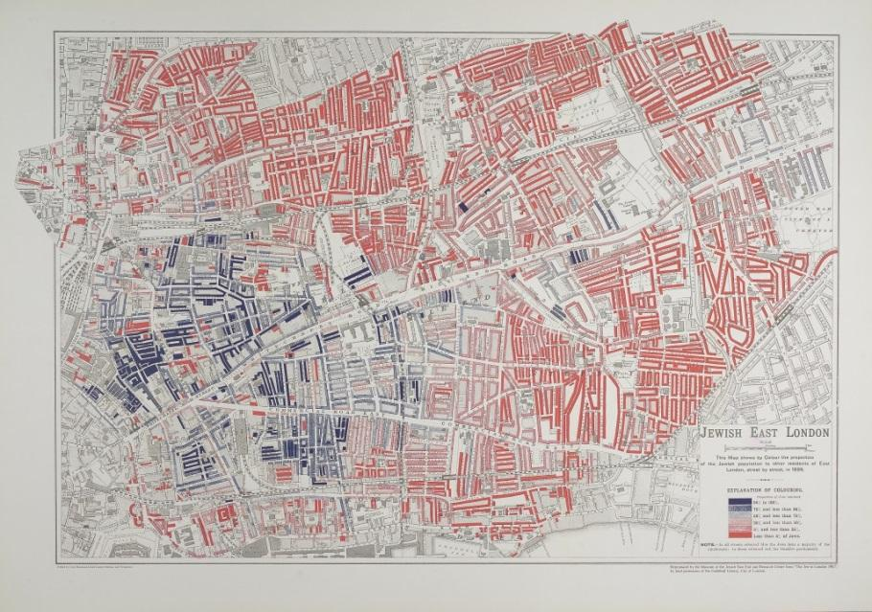

**The map shows (in blue) the Jewish communities near Spitalfields in Whitechapel.**

Blaming the Jewish Community for the Jack the Ripper Murders

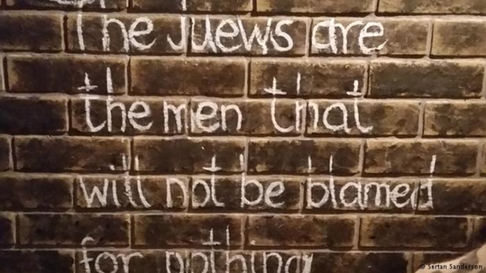These words were found near the scene of one of the Jack the Ripper murders. This gave rise to the idea that the Jewish community were responsible. The police had the words removed in order to avoid racial hatred.

John Pizer, nicknamed ‘Leather Apron’ was a member of the Jewish community and an early suspect in the Jack the Ripper murders. He was a boot finisher and so wore a leather apron. He had an alibi for the initial murders. However, many believed he was the killer and this increased tensions with the locals and the Jewish community.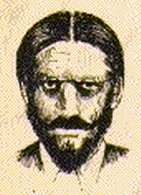

During the Ripper murders, anti-Jewish stories in newspapers such as the East End observer and the **Pall Mall Gazette** led to further harassment and street violence. Imaginary sketches of Jack the Ripper in local newspapers showed caricatures of Jews with hooked noses, dark beards and dark felt hats. Many people in Whitechapel believed that an Englishman could not have been Jack the Ripper and so they were convinced it must have been an Irishman or a Jew. The police were so alarmed by the feeling against the Jews that Whitechapel was filled with police reinforcements to prevent a riot.

Why didn’t H division catch Jack the Ripper?

What problems did H division face?

|  |  |
| --- | --- |
| **Things which made life difficult for H division** | **Things that helped H Division** |
| The work was often boring and sometimes dangerous. Pay was not especially good. All these things meant that the quality of recruits was variable. | *Most people felt that a police force was necessary – it was just their methods and priorities that were at fault.* |
| There was economic depression and widespread poverty of the 1870s-90s, which led to lots of public protests. When the police were called in, they were seen as upholders of unpopular government decisions. | *The poor people of Whitechapel could see that H Division provided real benefits: hosting soup kitchens; looking after stray children; and stopping runaway horses.* |
| Many people felt that the police were rather too concerned with promoting good manners among the residents of Whitechapel, at the expense of keeping them safe. |  |

|  |  |
| --- | --- |
| Because they were overstretched and understaffed, H division made no attempt to shut down fights and other criminal activities in some areas of Whitechapel, which they would have acted against in other neighbourhoods. |  |
| Very strong drink was affordable for all but the poorest and there were pubs and gin houses on every corner. Drunkenness often turned to violence, and alcoholics could turn to crime to get the money to buy more drink. |  |
| Sometimes the laws the police were supposed to enforce were just ignored – e.g. a law which made it compulsory for all dogs to be muzzled. |  |
| By 1888, it was estimated there were 62 brothels in Whitechapel and 1200 prostitutes. Prostitution was not illegal, but it was seen as a social problem that needed to be monitored. There was little understanding that the alternative to prostitution might be starvation. |  |

Why didn’t the police catch Jack the Ripper?

The Jack the Ripper Murders, August to November 1888

1. Murder of Mary Ann Nichols - **31 August 1888**
2. Murder of Annie Chapman - **8 September 1888**
3. First ‘Dear Boss’ letter arrives - **27 September 1888**
4. Murder of Elizabeth Stride & Catherine Eddowes - **30 September 1888**
5. Second ‘Dear Boss’ letter arrives - **1 October 1888**
6. Whitechapel Vigilance Committee receive ‘From Hell’ letter and human body parts through the post - **15 October 1888**
7. Murder of Mary Kelly - **9 November 1888**.

What were the police doing to try and catch the Ripper before the ‘double event’?

|  |  |  |  |
| --- | --- | --- | --- |
| Following up direct leads from the public & Interviewing key witness | Using evidence from post-mortems. | Following up indirect leads from articles by investigating journalists. | Following up indirect leads from articles by investigating journalists. |
| Following up on clues in the victims’ possessions. | Visiting lunatic asylums | Following up on coroners’ reports | Setting up soup kitchens |

What were the police doing to catch the Ripper after the ‘double event’?

|  |  |  |  |
| --- | --- | --- | --- |
| Questioning more than 2,000 lodging house residents. | House to house searches | Getting help from the Thames River police to question sailors in the docks. | Distributing 80,000 handbills |
| Getting neighbouring divisions of the Met to search opium dens. | Using disguises and dressing as prostitutes. | Putting more men on to the streets | Using the military to help. |

Why didn’t the police catch Jack the Ripper?

|  |  |  |  |
| --- | --- | --- | --- |
| Lack of forensics and technology | Rivalry between police forces | The Whitechapel Vigilance Committee | Media pressure and criticism |
| Conflicting expert evidence | Red Herrings – such as clues pointing to the jewish community. | Lack of financial reward and police mistakes | Conditions in Whitechapel |

To what extent did Whitechapel improve after the public outcry during the Jack the Ripper murders?

***The Bertillon System***

*The Bertillon System combined physical measurements, photography and record-keeping to identify repeat offenders. This system was adopted by the Met police in 1894 because of criticism of their lack of records during the Jack the Ripper case.*

***Fingerprinting*** *Fingerprinting was used by the Met police from the early 1900s.*

***Communication*** *In 1888 the police could only communicate from a distance using a whistle. Telephones were introduced although H Division did not have a telephone line at headquarters until 1901 and only installed a telephone exchange in the police station in 1907. In comparison, Glasgow police had police telephone boxes from 1891.*

***Travel*** *H Division introduced bicycles in 1909. However, Kent Police had introduced bicycles in 1896 and most other forces had them by 1905.*

***Improvements in living conditions*** *The Jack the Ripper murders led to a change of thinking about the causes of crime. The authorities began to link living conditions with crime. Instead of blaming the poor, they realised they had to improve the area. Street lighting was improved.*

***The Houses of the Working Classes Act (1890)*** *opened the way for the new London County Council to begin housing development schemes to replace slums with mass low cost housing.*

***The Public Health Amendment Act (1890)*** *gave more powers to local councils to improve toilets, paving, rubbish collection and other sanitary services.*

Did all of these changes work?

*Although there were no more serial killings, murders continued to occur regularly in the 1890s. More immediately, hooliganism increased as youths, pretending to be Jack the Ripper, frightened women. There was an increase in violence against prostitutes and an increase in burglary in the 1890s. Changes were brought to Whitechapel but they were often brought in very slowly.*