Edexcel History

**Crime and Punishment in Britain, c1000 to the present**

**Whitechapel, c1870-1900: Crime, policing and the inner city**

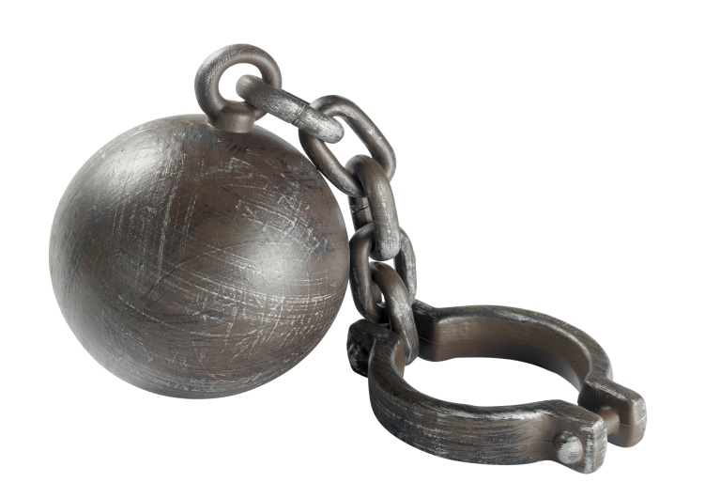

Revision Guide

***Questions 1, 2a and 2b are questions on the Whitechapel case study (see separate revision guide).***

Questions on the exam

Question 3*(4 marks)*

***Explain one way…***

* Asks you to compare a crime/punishment/method of law enforcement across two time periods.
* Allow five minutes to write your answer.
* Keep your answer brief.
* Refer to both time periods in your answer, using specific examples.

Question 4*(12 marks)*

***Explain why…***

* Asks you to explain the reasons why something happened.
* Allow about 15 minutes to write your answer.
* You are given two information points as prompts to help you. You are advised to use them.
* Higher marks are gained by adding in a point not covered in the prompts.

Question 5 or 6(you get to choose!)*(16 marks + 4 marks for SPaG)*

***How far do you agree?***

* Asks you to make a judgement about how far you agree with a statement.
* You must consider both sides of the argument (reasons that you might agree with the statement, and reasons why you might not).
* You should consider at least three points (each in its own paragraph). Make sure to link back to the question at the end of each paragraph.
* Think of each point as a weight on one side of the argument or the other. If you have more points which agree/disagree with the statement, then your conclusion should match.
* You should finish with a brief conclusion.
* Four extra marks are given for good punctuation, spelling and grammar.

Example questions

**[4 marks]**

Explain one way in which policing was similar in Tudor England and the early 18th century.

Explain one way that the system of community law enforcement in the 20th century was different from community law enforcement in the 16th century.

Explain one way in which treatment of witchcraft in the period 1500-1750 was similar to the treatment of conscientious objection in the 20th century.

Explain one way in which prisons were different in the mid 19th and late 20th centuries.

**[12 marks]**

Explain why the Normans made changes to crimes and punishments after the Norman conquest. You may use the following in your answer: the Forest Laws; the murdrum fine.

Explain why ‘trial by ordeal’ was used c.1000-c.1200. You may use the following in your answer: trial by hot iron; Church courts.

Why did the problem of highway robbery increase and decrease in the period 1700-1900? You may use the following in your answer: increased wealth; the death penalty.

Why was transportation used as a punishment in the period c1600-1850? You may use the following in your answer: American colonies; convict labourers.

**[16 marks]**

*‘In the period 1500-1700, the main aim of changes to punishments was retribution.’ How far do you agree?* Explain your answer. You may use the following in your answer: the Bloody Code; transportation to America.

*‘The most important factor in explaining witch hunts in the years c.1500-1700 was religion’. How far do you agree?* Explain your answer. You may use the following in your answer: *Demonologie*; the Civil War.

*‘Types of crimes have not changed since the beginning of the 19th century, only the methods used to commit them.’* How far do you agree? Explain your answer. You may use the following in your answer: fraud; race crimes.

*‘Attitudes in society were the most important factor influencing how criminal activity was dealt with in the period c.1500-c.2000.’* How far do you agree? Explain your answer. You may use the following in your answer: laws against witchcraft in the 16th century; conscientious objectors in the 20th century.

Crime and Punishment: 1000 – 1500

What you need to cover:

|  |  |
| --- | --- |
| Crimes | Crimes against the person, property and authority, including poaching as an example of ‘social’ crime.  Changing definitions of crime as a result of the Norman Conquest, including William I’s Forest Laws. |
| Punishments | The emphasis on deterrence and retribution, the use of fines, corporal and capital punishment. The use and end of the Saxon Wergild. |
| Law enforcement | The role of the authorities and local communities in law enforcement in Anglo-Saxon, Norman and later medieval England, including tithings, the hue and cry, and the parish constable. |
| Case study | The influence of the Church on crime and punishment in the early  thirteenth century: the significance of Sanctuary and Benefit of  Clergy; the use of trial by ordeal and reasons for its ending. |

**Crime, Punishment and law enforcement in Anglo-Saxon and Norman England 1000 - 1500**

Background:

England’s population in 1000 was around 2 million people and about 90% of people lived in the countryside. A powerful King and nobility made the law, but village communities helped to enforce the law at a local level. The Christian Church was another important influence on ideas about crime and punishment.

**Trends across the Anglo-Saxon and Norman period:**

1. **The power and influence of the King over crime and punishment grew**. Penalties were increasingly decided by the King rather than local communities.
2. **The role of the Christian Church increased** as the Church was interested in giving those who had committed crimes the chance to save their souls. Several great monasteries and abbeys were founded in the year 1000.
3. **The use of punishments, including capital punishment, increased.**  This was intended to boost the power and authority of the King across the land.

Crime in Anglo-Saxon England

**Petty theft** - Stealing small or low value items.

**Treason** - Betraying the King by helping his enemies or plotting to kill or replace him.

**Arson** - Setting fire to or damaging the property of the ruling classes.

**Crime against the person** - Crimes, like assault or murder, that cause physical harm to another person.

**Crime against property** - Crimes, like theft, robbery and arson that involve taking or damaging something that belongs to another person.

**Moral crimes** - Actions that didn’t physically harm anyone, or their property, but didn’t match up to society’s views on decent behaviour: for example, having sex outside marriage or not sticking to the rules or customs of the church (like not going to church on a Sunday).

**Public disorder** - Causing a nuisance in public such as being drunk.

**Counterfeiting coins** - Making fake money.

Law enforcement in Anglo-Saxon England

**Collective Responsibility** - Being responsible for the actions of other members of your community. If somebody broke the law it was up to everyone in the village to take action.

**King’s Shire Reeve** - A local official, appointed from the community to bring criminals to justice. The term ‘shire reeve’ later became ‘sheriff’.

**Tithings** - English shires were divided into smaller areas called ‘hundreds’. Each hundred was divided into ten ‘tithings’. All the men aged 12 and over in a tithing were responsible for the behaviour of the others. One man from each hundred and one man from each tithing was expected to meet regularly with the King’s Shire Reeve.

**Hue and Cry** - Anyone who witnessed a crime could raise the ‘Hue and Cry’. This was literally shouting for help. Everyone who heard it was expected to help chase and capture the suspects.

**Taking Oaths** – Anglo-Saxon justice relied heavily on religion when deciding if someone was innocent or guilty. An accused person could swear their innocence under oath and could call upon others in the community (oath helpers) to support their claims. Many walked free as they had taken an oath but repeat offenders were not given the option of taking an oath.

**Trial by ordeal** – In cases where there was not enough evidence to prove if a person was innocent or guilty, the accused could be tried by the church authorities. A trial by ordeal was seen as a way of testing whether the accused was innocent or guilty in the eyes of God. There were different trials:

1. **Trial by hot iron/hot water**: Heat was used to burn the accused’s hands, which was then bandaged; if the burn healed well, this was seen as a sign that God judged the person to be innocent.
2. **Trial by cold water**: In a cold water ordeal, the accused was thrown into water with their arms tied; anyone who floated was judged guilty, while anyone who sank was judged innocent and hauled up again. An innocent person was accepted by the water as pure, whereas the guilty had been rejected by it.

Punishments in Anglo-Saxon England

**Trial by hot water**

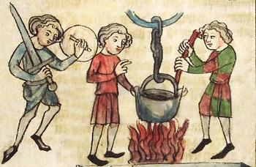

**Wergild** – Murder was sometimes punished by fines paid to the victim’s family (a wergild or ‘man price’ was paid). These fines were seen as compensation for the loss of life and were intended to reduce blood feuds (ongoing fighting) in the future. The amount paid

depended on social status, for example the price for killing a prince was 1500 shillings but only 40 shillings for killing a serf (or peasant).

**Capital punishment –** The death penaltywas either used for retribution (revenge) or as a deterrent (designed to put others off committing the crime). Treason and arson were punished by execution – usually by hanging.

**Corporal punishment/Maiming** – Causing physical harm such as having a hand, foot or an ear cut off, an eye gouged out or their tongue cut out. The Church advised maiming rather than execution for petty theft as they believed it would give the criminal time to seek forgiveness from God. This punishment was designed as a deterrent or a warning to others.

**The stocks and the pillory** – The pillory secured the arms and neck and the stocks secured the ankles. The stocks or pillory were placed in the centre of a town or village. Public punishments were a combination of physical pain and humiliation as the public may throw rubbish or verbally abuse the victim.

**A summary of crime and punishment in Anglo-Saxon England**

|  |  |  |
| --- | --- | --- |
| **Crime** |  | **Punishment** |
| **Crimes against the person** | **Murder**  **Assault**  **Public disorder** | **Wergild**  **Maiming**  **Stocks or Pillory** |
| **Crimes against property** | **Theft**  **Counterfeiting coins**  **Arson** | **Fines or maiming**  **Hand chopped off**  **Hanging** |
| **Crimes against authority** | **Treason**  **Betraying your lord** | **Hanging** |

**Crime, punishment and law enforcement under the Normans 1066 - 1154:**

During the Norman period, the influence of the King over the law increased. William the Conqueror wished to make his power and authority visible after his victory at Hastings in 1066 and harsh punishments such as execution increased. Punishment and law enforcement became more centralised and fewer decisions were taken by local communities. William introduced the Feudal System, where everybody owed money or service to the class above them. Anglo-Saxon nobles were replaced by Norman nobles and Anglo-Saxon Serfs were forced to work for Norman nobles. Resistance in York and East Anglia was met with brutal force and it is estimated that 100,000 died of starvation as a result of food shortages caused by the punishments (burning of crops and livestock) that William ordered. Castles were also introduced across the land to keep a careful watch on communities and to look intimidating, showing the King’s authority over law and order in England.

**New crimes under the Normans:**

**Running away -** Anglo-Saxon Serfs (or peasants) were legally bound to work for their lord as part of the feudal system and were not allowed to leave their village. If they did, they were hunted down and severely punished**.**

**Murdering a Norman -** If a Norman was murdered by an Anglo-Saxon, the murderer could be caught and executed, or a Murdrum fine (see punishments) was placed on the community.

**Poaching -** Illegal hunting on land that belongs to someone else. As William declared large stretches of England’s countryside to be ‘Royal forests’ under the Forest Laws, peasants could no longer use the land to graze animals, to access natural resources or for hunting.

**Social Crime -** A social crime is an action that is technically against the law but which most people in society do not disapprove of. Poaching is an example of a social crime as the forest laws led to much bitterness and people saw them as unfair and unjust so they did not frown upon those who broke the law.

**The Feudal System**. Everybody owed services or money to the class above. Serfs (or peasants) were forced to work for Norman nobles.

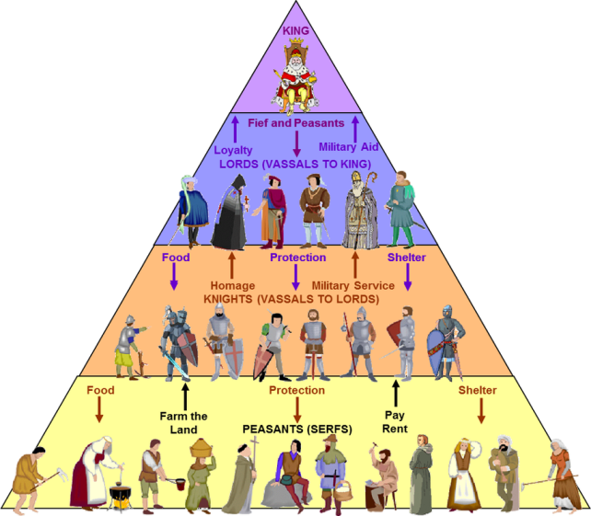

Law enforcement under the Normans

**Forest Laws –** The Forest Laws meant that what had previously been common land – where peasants had the right to graze animals, take firewood or catch a few rabbits – was now strictly controlled by the King.

**Foresters –** The King hired men to work as ‘foresters’ to enforce the forest laws and catch poachers and anyone else who did not have permission to come into the forest.

Punishments under the Normans

**Castration, branding and blinding** – Castration is the removal of the testicles and was sometimes used against poachers. Poachers could also face execution, blinding or other corporal punishment such as branding where the criminals flesh was burnt with a hot iron. These were intended to be a deterrent for other poachers.

**Outlaws** – Any man aged 14 or older who tried to avoid trial or punishment by running away was declared an outlaw. Women who ran away were said to be ‘waived’. Outlaws or waived women lost the protection of law and so could be killed or harmed without any legal consequences for the person responsible.

**Murdrum fines** – If an Anglo-Saxon killed a Norman there was a special penalty known as the Murdrum fine. This was a large sum of money paid by the hundred where the body was found and showed a continuation from the Anglo-Saxon idea of collective responsibility for crimes.

|  |  |
| --- | --- |
| **Change under the Normans** | **Continuity under the Normans** |
| There was a trend towards centralisation of law enforcement under the King rather than local communities. For example, Wergilds were ended by Normans and fines were paid to the King’s officials rather than victims of the crime and their families. | The idea of the King’s Peace (everyone having the right to be safe from crime) was continued but called the King’s Mund instead. |
| The authority of the King was further extended through the Feudal System, harsher punishments, Forest Laws and Castles. | The use of Murdrum fines was a continuation of the Anglo-Saxon idea of collective responsibility. |
| There was an increase in the number of crimes punishable by death or mutilation under the Normans. For example, poaching became a crime and was punishable by death or mutilation. | Trial by ordeal continued as in Anglo-Saxon England. |
| Trial by Combat was introduced. This was used to settle disputes over large sums of money or land. The two people involved in the dispute would fight using swords or large sticks until one died or gave in. If you gave in you were put to death anyway! | The Hue and Cry continued under the Normans and so did the use of Tithings where the community was responsible for bringing criminals to the authorities. |

Crime, punishment and law enforcement in the later middle ages 1154 - 1500

**The Impact of Henry II**

**Henry II became King in 1154 and introduced important changes to crime and punishment in England that meant more centralised control over the courts and legal system.**

1. **The Assize of Clarendon - In 1166 he reorganised the courts and set up prisons for those awaiting trial.**
2. **Justices in Eyre – Henry II ordered royal judges (Justices in Eyre) to visit each county twice a year to hear the most serious criminal cases.**

**Due to the development of bigger towns, there was a shift away from local communities dealing with crime to more use of government officials. Similar law enforcement methods could now be used in all areas.**

**New Crimes:**

**Heresy -** Disagreeing with the teachings of the Church became a crime as some began to question the teachings and practice of the Church in the 13th and 14th Centuries. People who committed Heresy were known as Heretics. The punishment for Heresy was burning at the stake.

**Asking for Higher Wages -** The Statute of Labourers 1351 made it a crime to ask for higher wages. This was mainly in response to the Black Death in 1348 which had killed one third of the population and meant peasants started to demand higher pay. This also marked a change as parliament introduced the law and not the King!

**High treason** – This was plotting to kill or betray the King. This was seen as a crime against God as well as the King.

**Changes to Law enforcement in the later middle ages:**

**Parish Constables -** These were unpaid law enforcement officers introduced from the 13th/14th century.

**Coroners –** King Richard I introduced Coroners to deal with suspicious deaths in 1194. They decide the cause of death.

**Justices of the Peace -** These were initially Knights who were appointed to keep the peace in areas that were unruly but were extended to all areas by 1327. They met four times a year to enforce the law and carry out magistrate (judge like) duties.JPs could arrest heretics showing that the government and church worked together.

**New Punishments:**

**Burning at the Stake -** In 1401 a law introduced burning at the stake as a way of *‘purifying a corrupt soul’* and it involved being tied to a stake and burned alive. This severe punishment was intended as a deterrent for heretics.

**Hanging, drawing and quartering –** This was the punishment for high treason and involved the convicted person being semi strangled, revived, having the abdomen cut open and intestines drawn out. After death, the limbs were cut off and sent to different areas of the country for display. This was meant as a powerful deterrent to those who would challenge the King.

**Continuity in the later middle ages**

Townspeople were still expected to play their part in law enforcement and the newly developing towns were divided into wards for that purpose.

Manor Courts were still used to deal with disputes between the Lord of the Manor and local people.

**Continuity and change in law enforcement and punishment from 1000 – 1500**

|  |  |  |  |
| --- | --- | --- | --- |
|  | **Anglo-Saxon** | **Norman** | **Later Medieval** |
| **Law Enforcement** | Community responsible for enforcing the law | Community responsible for enforcing the law.  Growing authority of the King and his officials. | Community enforcement continues alongside increasingly centralised systems for upholding the law. |
| **Punishment** | Fines, stocks, pillories, property confiscated, physical punishment, maiming and execution by hanging or burning. | Fines, stocks, pillories, physical punishments, maiming.  Increase in execution by hanging for new crimes. | Fines, stocks, pillories, physical punishments, maiming and hanging.  Burning at the stake and hanging, drawing and quartering introduced. |

CASE STUDY – The Influence of the Church on crime and punishment

**Why the church was important in Medieval England:**

1. The Clergy (priests and monks) were often the most educated members of society and could influence peoples’ thinking. The idea of Heaven and Hell were very powerful in controlling peoples’ actions.
2. Churches and Cathedrals were the largest buildings in most towns or villages and reminded people of God’s power on earth.
3. The Church owned one fifth of the Country’s wealth and collected one tenth of all earnings in Church taxes.

**How could the Church influence crime and punishment?**

**Trial by ordeal** – The Church was in charge of Trials by Ordeal as the idea was that God was deciding if someone was innocent or guilty. Members of the Clergy were tried by consecrated bread where if the priest choked, they were guilty. This was considered a far less dangerous trial for priests. The Pope ordered Priests to stop helping with Trials by Ordeal in 1215.

**Church Courts** – Members of the Clergy were tried in separate courts and punishments were more lenient, much to the annoyance of many Kings. The Church very rarely used the death penalty but used confession or enforced pilgrimage instead.

**Benefit of Clergy** – This was the right of members of the clergy to be tried in Church Courts. If an accused person could read Psalm 51 of the bible they could also claim Benefit of Clergy and would be tried in a Church Court. Psalm 51 became known as ‘the neck verse’ because knowing it could save your neck.

**Offering Sanctuary** – Some churches offered a hiding place (or sanctuary) to those accused of a crime. The Church would report the crime but the accused person was given the chance to swear an oath agreeing to leave the country within 40 days. If the accused did not leave, they were outlawed. Offering Sanctuary was ended by Henry VIII in 1536.

**The Church Vs The King**

Many Kings during the Middle Ages did not like the amount of influence the Church had over crime and punishment as Churches wanted to focus on rehabilitation of criminals rather than retribution or deterrence. Kings also felt that the Church was too lenient on member of the clergy who were escaping proper justice. Henry II tried to challenge the authority of the Church in the 12th century through the Constitutions of Clarendon as he wanted to standardise law and order or make it the same for everyone. Trial by Jury was brought in after the ending of trial by ordeal in 1215.

Crime, Punishment and law enforcement in early modern England 1500 – 1700

***What you need to cover:***

|  |  |
| --- | --- |
| Crimes | Continuity and change in the nature of crimes against the person, property and authority, including heresy and treason.  New definitions of crime in the sixteenth century: vagabondage and witchcraft. |
| Law Enforcement | The role of the authorities and local communities in law enforcement, including town watchmen. |
| Punishments | The continued use of corporal and capital punishment; the introduction of transportation and the start of the Bloody Code. |
| Case studies | The Gunpowder Plotters, 1605: their crimes and punishment.  Key individual: Matthew Hopkins and the witch-hunts of 1645–47.  The reasons for their intensity; the punishment of those convicted. |

**Background and trends across the period:**

* The changing religious situation in England led to many religious beliefs and activities being newly classed as crimes.
* English Civil Wars during 1600s causing instability
* Social divisions, hatred against women and political instability leading to a rise in witch hunts
* Ruling elite still using the law to protect their own position in society

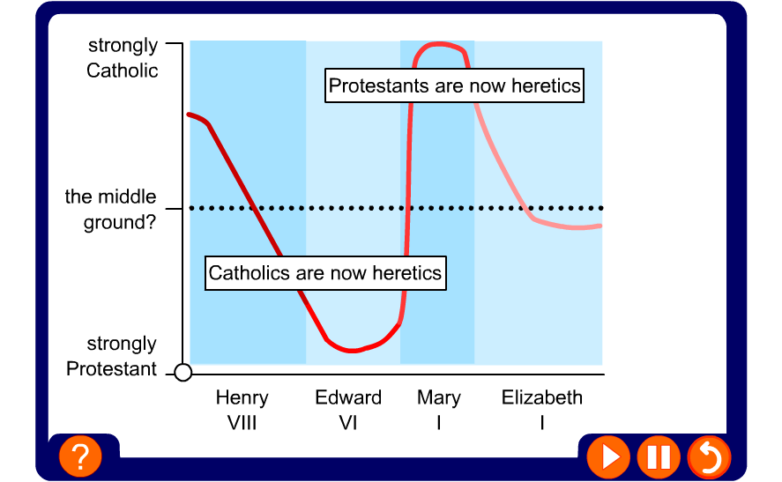

Changes in Religion 1534 – 1625

|  |  |  |
| --- | --- | --- |
| Monarch | Religious Changes | Crimes and Religion |
| Henry VIII – 1509 - 1547 | In 1534, Henry declared himself head of the Church of England. He closed down Catholic monasteries and seized wealth and land. | Catholics were executed for treason if they would not take the Oath of Supremacy that acknowledged Henry as the Head of the Church. Protestants could be executed for Heresy. |
| Edward VI – 1547 - 53 | Edward was brought up Protestant and brought in an English prayer book, allowed priests to marry and made churches plainer – all these actions were typically protestant. | Some Catholic Bishops were imprisoned in the tower of London. Two people were executed for crimes of Heresy. |
| Mary I – 1553 – 58 | Mary was a strict Catholic and tried to restore the Catholic Church. She made the Pope head of the Church again. | Almost 300 people were executed as heretics for refusing to follow the Catholic faith during Mary’s reign. |
| Elizabeth I – 1558 – 1603 | Elizabeth tried to find a ‘middle way’ in religion. She wanted to create a Protestant Church that did not challenge too many Catholic traditions. | Elizabeth passed several new laws:  The Act of Uniformity – Everyone had to go to Church on a Sunday or pay a fine. Those who refused were guilty of recusancy.  The Act of Supremacy – Catholics had to swear allegiance to Elizabeth as head of the Church.  After a rebellion in 1569, Elizabeth executed many Catholics and prosecuted more for recusancy. |
| James I – 1603 – 25 | James was a protestant and was tolerant to Catholics until the Gunpowder plot of 1605. | James introduced strict anti-Catholic laws:  1605 Popish Recusants Act – this forced Catholics to swear loyalty to the King and pay heavy fines for not attending Church. |

Crimes in Early Modern England – 1500 – 1700

**Heresy** - Heresy was a crime against the Church and an offence to God. Heretics were those who went against the religion of the monarch.

**Treason** - Treason was the crime of betraying your country or going against the authority of the King or Queen.

**Heresy & Treason** – The two crimes became connected in this period as all monarchs from Henry VIII onwards (except Mary I) were head of the Church of England. Therefore a crime against the King or Queen was now also a crime against the Church.

**Recusancy** – Refusing to attend Church of England services.

**Vagabondage or Vagrancy** – After 1500, people began to move around more in search of jobs and with the closing of the Monasteries, the poor had nowhere to turn to. Unemployed and homeless wanderers were known as Vagabonds or Vagrants and this became a crime.

**Rural Crimes** (Poaching on enclosed land)– Large areas of land were enclosed by wealthy landlords and so the rural poor no longer had access to rivers for fishing or land for hunting. The 1671 Game Act made it illegal to hunt rabbits or fish on enclosed lands.

**Witchcraft** – broadly means the practice of, and belief in, magical skills and abilities that are able to be exercised by individuals and certain social groups. Most people in this period believed Witchcraft existed and punishments became harsher as new laws meant Witchcraft was to be tried in ordinary courts rather than lenient Church courts.

**Smuggling** – With the introduction of import duties (taxes on goods from abroad) on products such as alcohol or tea, many started to smuggle goods in to avoid the tax and make profits.

**Puritan laws** – After Parliament’s victory in the English Civil War, Oliver Cromwell became Lord Protector from 1653 – 58. During this period some activities such as sports, alcohol and Christmas celebrations were banned. Cromwell was a radical Protestant (or Puritan) and believed people should focus on religion.

Law Enforcement in Early Modern England – 1500 – 1700

**The Vagrancy Act of 1547** A person in a new town without work for 3 days was branded with a V and sold as a slave for two years. This law only lasted 3 years as it was so harsh.

**1597 Act for the Relief of the Poor** - This law included harsh punishments such as whipping or burning the ear using a hot iron to act as a deterrent to vagrants.

**1601 Poor laws** – These laws separated the ‘deserving poor’ (those who were not fit to work) or the ‘undeserving poor’ (those fit to work). The deserving poor were to be given poor relief payments by local parishes and the undeserving poor were to be punished by branding, whipping or being sent to new houses of correction where they would be forced to work.

Law enforcement in the Towns:

**In 1500 the population of England was 2 ½ million and by 1700 it was 5 ½ million. Many moved to towns such as London, Liverpool or Bristol to look for paid work and this changed the nature and rate of crime as more opportunities for theft arose in a crowded town. Crime grew in towns as pickpocketing was easier, there was high unemployment, it was easier to get away with crime and increasing wealth meant some people’s homes or businesses were targeted for burglary or fraud.**

**Night Watchmen** – Watchmen were unpaid volunteers who would take it in turns to patrol the local area between 10pm and dawn. They would carry a lamp, ring a bell to warn people to go home and were overseen by the town constable.

**Town Constable** – The town constable was employed by the town authorities, could arrest suspects without the need for a warrant from the JP and was expected to turn serious criminals in to the courts.

**Thief Takers** – Some victims of crime resorted to using thief takers as town constables and night watchmen were not very effective. The thief taker was paid a reward for catching a criminal and delivering them to the law. However, some were already criminals and informed on rival criminals to make money. An example of this is Jonathan Wild who secretly led a gang of thieves who claimed rewards when they handed in goods they had stolen. He was found out and executed in 1725.

**Jonathan Wild – Thief Taker General**

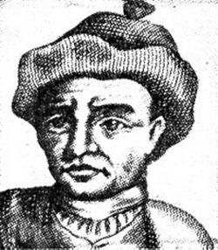

Punishments in Early Modern England - c.1500 - c.1700

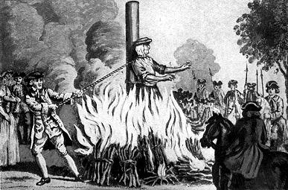**Punishments in this period still focused on retribution and deterrence as they had for the past 700 years. However, some new punishments emerged towards the end of the period such as transportation.**

**Burning at the Stake for Heresy** - The person being punished was tied to a wooden post while a fire was lit beneath them. Death was caused by breathing in fumes or from the shock of the burns.

**Recanting** – To avoid being burned at the stake a person could recant or make a public statement that they had changed their religious beliefs.

**Excommunication** – The action of officially excluding someone from participation in the sacraments and services of the Christian Church.

**Early Prisons** – In the early 16th Century, prisons were used to hold petty criminals while they awaited trial or punishment and they were usually in a castle or gatehouse. **Bridewell prison** was opened in 1556 and was a purpose-built facility to house criminals or vagabonds who were made to do hard labour to pay for their upkeep.

**The Bloody Code** – In the 17th Century, more and more crimes started to carry the death penalty. There were 50 capital crimes (crimes that carry the death penalty) by 1688 although pardons could be received for previous good character or pregnant women could ‘plead for belly’.

**Transportation to North America** – During the reign of James I (1603-25) transportation to the new English colonies in North America became a punishment. 50,000 – 80,000 people were transported by 1770. Convicts had to serve 14 years doing tough manual labour or 7 years for lesser crimes. Most convicts never made it back to England.

Case Study – The crimes and punishments of the Gunpowder plotters, 1605

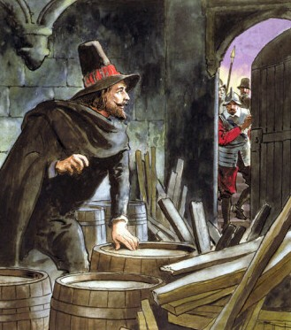***Why did the Gunpowder plotters act against the crown?***

Elizabeth I died in 1603, after reigning over England for 45 years and Catholics across the country were hopeful that the new King, James I would allow them more religious freedom. However, over time it became clear that James was prepared to introduce stricter anti-Catholic measures and so Catholics were disappointed. The plotters were all Catholics who were led by Robert Catesby who had a history of Catholic resistance against the crown.

***What was the plan?***

The conspiracy aimed to set off an explosion that would kill the king and the elite of Protestant England at the opening of Parliament on 5 November 1605. The conspirators first met on 20 May 1604 to begin organising the attack on Parliament. They rented a house in central Westminster next to the Parliament building. Guy Fawkes pretended to be a servant who was looking after the house while his employer was away. They then rented a cellar directly under the House of Lords and packed it with an estimated 36 barrels of gunpowder.

***What went wrong?***

On 20 October 1605, Lord Monteagle received a letter warning him not to attend the opening of Parliament. Monteagle gave the letter to Robert Cecil (the King’s Spy master) who ordered Parliament to be searched. It was in this raid that Guy Fawkes was discovered and arrested.

***Punishments of the plotters***

Guy Fawkes and his fellow conspirators were tortured to extract confessions under the King’s orders. Guy Fawkes was stretched on the rack at the tower of London and finally confessed on 17 November (12 days after his arrest). The conspirators were found guilty of treason at trial in January 1606 and were sentenced to be hanged, drawn and quartered.

***Long term consequences of the plot***

The **1605 Thanksgiving Act,** ordered that the events of 5 November should be commemorated each year and Catholics were banned from working in the legal profession or from becoming officers in the armed forces.

The **1606 Popish Recusants Act** forced Catholics to take an oath of allegiance to the English Crown. They were also forced to take part in Church of England services and rituals – or pay fines.

The plot continued to have an impact on Catholics for centuries after the event. They were restricted from voting, becoming M.Ps or owning land. The could not vote in any elections until 1829.

Witchcraft and the law – c.1500 - c.1700

Attitudes to Witches:

Witches were believed to have made a pact with the devil in return for special or magical powers – including flying and the ability to make people, or farm animals sicken and die. Witches were sometimes identified by their apparent association with domestic animals. A cat, dog or even a spider could be a Witch’s familiar (the devil in the shape of an animal) helping the witch to do her evil work.

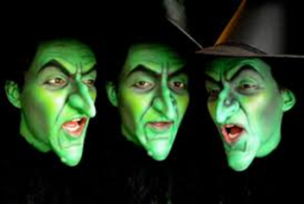

Why was Witchcraft punished more severely by the authorities in the late 16th Century?

1. **Changes in the law.** During the Middle ages, witchcraft was a crime tried in church courts. In 1542, Henry VIII made witchcraft a criminal offence to be tried in ordinary courts. In 1563 Elizabeth I passed a new law that stated if a witch tried to kill someone they would receive the death penalty. In 1604 James I passed a law giving the death penalty for anyone summoning evil spirits.
2. **Economic problems in the late 16th Century** meant falling wages and high unemployment. This increased tension and meant that the death of livestock or failure of crops was blamed on Witchcraft.
3. **The rising fear of Vagabonds** meant the rich were far more likely to accuse the poor of Witchcraft.
4. **James I’s Demonologie**: James I was an enthusiastic witch hunter and shared his thoughts in a book called Demonologie. When he became King he encouraged further Witch-hunts and his ideas had an influence on a wide audience.
5. **The English Civil Wars:** The wars began in 1642 and caused a great deal of social upheaval, disruption and uncertainty. The wars created a climate of fear in which people were attracted to superstitious ideas such as witchcraft.
6. **Attitudes to Women** – Women were expected to focus on domestic duties in the 17th Century and were the property of their father or husband. If they did not follow this stereotype then they could be suspected. Many of the women accused were ‘cunning’ or ‘wise women’ who were suspected of witchcraft as the community believed they had the power to heal. Many older women were vulnerable to accusations as they were poor and not married.
7. **Religion** - Human existence was seen as a struggle between good and evil – God and the Devil. Superstition led to many believing that witches were doing the devil’s work on earth. After Henry VIII became head of the church of England, witchcraft became a crime against the King and the State. People feared the ‘old’ catholic religion and this led to people trying to cleanse society by looking for witches

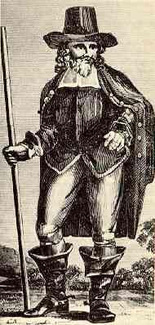Case Study: Matthew Hopkins – Witchfinder General

In 1645 a former Essex Lawyer and self-proclaimed ‘Witchfinder General’ set about hunting down the witches in the East of England. Justices of the Peace were officially responsible for finding witches and Matthew Hopkins was employed by a JP in Essex and East Anglia to find them.

***Interrogation:***

Hopkins used a range of interrogation methods to secure confessions such as restricting water, food and sleep. He would also look for moles, birthmarks or skin blemishes as evidence of a teat (nipple) used by familiars to suckle blood. When he extracted a confession he would expect the accused to include the names of other potential witches he could visit.

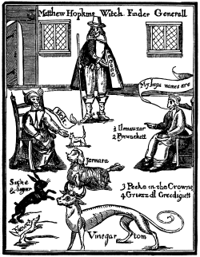***Punishments for witchcraft:***

The most notorious method of judging guilt was the ‘swimming test’ which involved drowning the accused. The guilty would float and the innocent would sink. This method was only used in some communities and not by Hopkins.

Around 1,000 people were executed for witchcraft between 1542 – 1736 and they were most commonly hanged. Hopkins managed to cause a huge panic in the Eastern region with accusations against 117 people in Sudbury alone. Around 112 individuals were executed by hanging as a result of Hopkins’ investigations.

***The decline in accusations of witchcraft:***

Matthew Hopkins died of tuberculosis in 1647 and in the second half of the 17th century many started to consider the idea of witches as foolish and muddled or believed accusers like Hopkins were tricksters trying to take advantage of people’s gullibility. During the Enlightenment years of the 17th and 18th centuries, thinkers and academics started to ask for more scientific evidence and reason behind ideas. The Royal Society was established in 1660 and brought thinkers and Scientists together from a wide range of Scientific fields.

Crime and Punishment: c.1700 – c.1900

*What you need to cover:*

|  |  |
| --- | --- |
| Crimes | Continuity and change in the nature of crimes against the person, property and authority, including highway robbery, poaching and smuggling.  Changing definitions of crime exemplified in the ending of witchcraft prosecutions and treatment of the Tolpuddle Martyrs. |
| Punishments | Changing views on the purpose of punishment. The use and ending of transportation, public execution and the Bloody Code. Prison reform, including the influence of John Howard and Elizabeth Fry. |

|  |  |
| --- | --- |
| Law enforcement | The role of the authorities and local communities in law enforcement, including the work of the Fielding brothers. The development of police forces and the beginning of CID. |
| Case studies | Pentonville prison in the mid nineteenth century: reasons for its construction; the strengths and weaknesses of the separate system in operation.  Key individual: Robert Peel – his contribution to penal reform and to the development of the Metropolitan Police Force. |

**Background and trends**

From 1700-1900 there were ***many changes in society*** that had a significant impact on crime and punishment***. Rapid population growth and urbanisation*** meant more opportunities for crime, as rich as poor now lived more closely together. Mass migration from countryside to town made enforcing the law more difficult, as it was harder to keep track of people, and extreme poverty in some areas of big cities, like London, saw the growth of a criminal underclass.

There were also ***important developments in ideas and attitudes*** that led to new ways of catching and dealing with criminals. For example, in the 19th century prisons were intended to reform criminals and not just lock them away.

***A number of individuals*** had a significant impact on changes in law enforcement and punishment at this time, including: the prison reformer John Howard; and the founder of the Metropolitan Police, Robert Peel.

Crime, c.1700 - c.1900

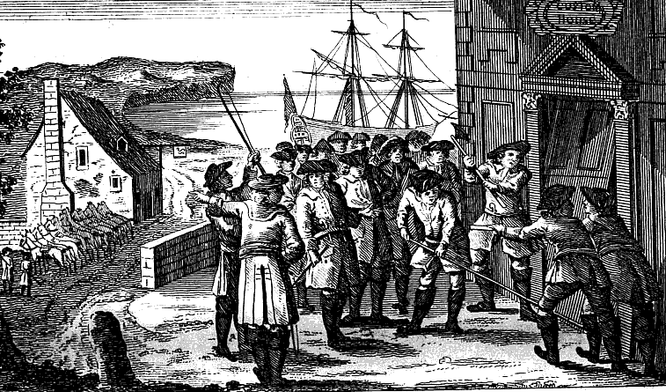

**The Hawkhurst Gang raiding a customs house**

**Smuggling - continuity and change**

* **17th century** (1600s) - the government introduced import duties on a range of goods from abroad. Smugglers brought goods into the country without paying the new duties, so could sell their goods cheaper than other traders.
* **18th century** (1700s) - more goods (including cloth, wine and spirits) were taxed, and smuggling activity increased.
* Large smuggler gangs became established e.g. the Hawkhurst Gang in Kent. Gangs were far more organised and operated on a larger scale than earlier smugglers.
* Smuggling was a ‘social crime’. Many people benefitted from the cheaper smuggled goods and did not see it as a serious wrongdoing. Both the local poor and members of the powerful upper classes helped the smugglers and bought the cut-price goods. This popular support made it harder for the authorities to track down and arrest smugglers.
* Customs officers also faced practical difficulties. Smugglers often worked at night, unloading cargoes under cover of darkness, and there was no police force to man the coastline.
* Smuggling became less common in the end, but only because import duties were reduced (during the 1780s and then again in the **19th century**) which made it less profitable.

**Highway robbery**

Highway robbery became more common during the 18th century. Some reasons for this include:

* There were many open, lonely areas outside towns where travellers could be held up.
* There was no police force and local constables did not try to track highwaymen across the counties.
* As trade increased there was more need to move goods and money around. There were no cheques or debit cards, and only a few banks where money could be left for safe-keeping; so business people, and ordinary travellers, often carried large sums in cash.

Gradually highway robbery began to decrease:

* ***1772 – the death penalty was introduced for anyone found armed and in disguise*** on a high road.
* Travellers no longer carried large amounts of money as the number of banks grew and the banking system became more sophisticated.
* Mounted patrols were set up around London and high rewards encouraged informers. Highwaymen had more of a chance of being caught.

**Highway robbery** continued into the 19th century, but after 1815 the crime became less common. The last reported case was in 1831.

**Poaching: continuity and change**

* Poaching continued to be a widespread crime – like with smuggling there was a rise in gangs operating on a large scale.
* The ***1723 Black Act*** was passed to try to deal with these gangs, by making poaching a capital offence. The Act also made it illegal to blacken your face, carry snares, or even own certain types of dogs which could be used for poaching.
* In ***1823 the Black Act was repealed*** as part of a large number of legal reforms led by Robert Peel. Poaching was still illegal but would no longer be punishable by death.

**Witchcraft**

In 1736 a new Witchcraft Act was passed which decriminalised witchcraft. People no longer believed in witches. Those who claimed to be ‘witches’ were now seen as fraudsters out to take advantage of others – the punishments for claiming to be a witch were now much less severe.

**The Tolpuddle Martyrs**

The case of the Tolpuddle martyrs shows how the government dealt with threats to authority at the time of the French Revolution (1789), when it was feeling vulnerable. It also shows how changing attitudes could influence the government’s definitions of crime.

* ***February 1834*** – in the village of Tolpuddle in Dorset, a farm labourer called Goerge Loveless and five others were arrested and accused of ‘administering an illegal oath’. They had broken an old law intended to stop sailors in the Navy organising mutinies.
* The real motive for their arrest was to stop their political activities. They had formed a ‘friendly society’, an early form of trade union. They wanted to protest about their low wages.
* The men were sentenced to seven years’ transportation to Australia – the most severe sentence available to the judge handing out the penalty.
* News of the conviction spread very fast (the Old Crown Court in Dorchester was one of the earliest to have a press gallery). Mass protests were organised in support of the men – a demonstration in London was attended by 100,000 people, and a petition was signed with 200,000 signatures.
* The men were sent to Australia anyway, but were pardoned four years later. They returned to a hero’s welcome.

Punishments, 1700-1900

**The decline of the death penalty**

* People began to question the harshness of the Bloody Code. Juries became unwilling to condemn people to death.
* Many believed alternative punishments should be found.

**The end of public executions**

* The Bloody Code had been based on the idea of being a deterrent. Increasingly, however, public executions had turned into exciting spectacles which had a carnival atmosphere.
* Moreover, the large crowds which gathered to watch an execution became themselves opportunities for further crime, such as pickpocketing.

**Transportation to Australia**

* Britain lost the American colonies in 1783, so criminals began to be sent to Australia instead.
* Transportation was seen as an effective deterrent and alternative to the death penalty. It would keep numbers lower in prisons, and the criminals would help to populate the new colony of Australia.
* Prisoners condemned to be transported were held in disused ships called hulks before making the three month journey across to Australia. There they worked for settlers, who provided them with basic food and housing.
* Transportation to Australia ended in 1868:
* *In Australia, many people blamed the British criminals for rising crime rates and a lack of jobs*
* *In Britain, some people said that the three month sea-journey was inhumane while others felt that transportation was too lenient. Moreover, British prisons were becoming more of an option for punishments.*

**Prison reform**

Before the 18th century (1700s) prisons had mostly been used just for holding suspects in the run-up to their trial. During the 18th and 19th centuries (1700-1800s), the use of prisons as a punishment grew.

The great debate about prisons: punishment or rehabilitation?

|  |  |
| --- | --- |
| Punishment | Rehabilitation |
| Prisoners should be kept in harsh conditions. | Prisoners should be treated humanely. |
| Prisoners should perform hard labour, and sometimes completely useless work e.g. the treadmill. | Prisoners should perform work which is useful for society, and which prepares them for going back into the community. |

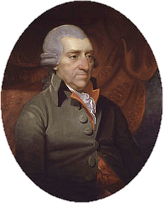Prison reformers were part of the ‘rehabilitation’ category of thinkers.

**John Howard (born 1726)**

* Was outraged by conditions in the Bedfordshire county gaol.
* Toured other prisons, looking for good examples to remodel the gaol on. Almost everywhere, conditions were bad. In ***1777 he published* The State of Prisons in England and Wales**whichprovided detailed evidence for other prison reformers.
* Made visits to individual gaolers around the country in order to persuade them to improve their practices
* 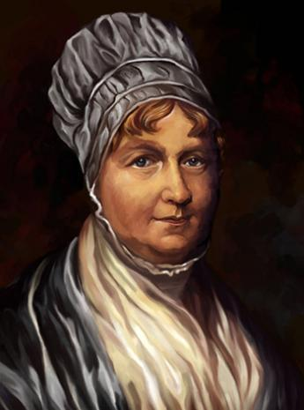Brought about decent food and water, useful work, Christian teaching, private cells to allow reflection on crimes, and a wage for gaolers so they wouldn’t exploit prisoners.

**Elizabeth Fry (born 1780)**

* In 1813, visited Newgate prison and was shocked by the conditions. Some prisoners had been detained without trial. Women and children lived alongside dangerous prisoners in filthy, overcrowded conditions.
* Taught sewing and led bible classes at Newgate in order to encourage rehabilitation.
* In 1817, helped set up the Association for the Reformation of Female Prisoners at Newgate to campaign for better conditions.
* Helped to ensure that female warders were introduced to work with female and child prisoners.
* **1853 - Brixton prison opened solely for women**
* **1899 - Children no longer sent to prison with adults**. Special reformatory prisons set up, called Borstals.

Law enforcement, 1700-1900

**Early 18th century (1700s)**

* Law continued to be enforced using a combination of old methods e.g. parish constables, watchmen, part-time soldiers.
* Some towns had salaried constables and watchmen, but they were low-paid and the job had low status.

**1748, Bow Street Runners**

* Crime fighting team established in London by the Chief Magistrate, **Henry Fielding**, who had offices at Bow Street. His brother, **John Fielding** was also involved.
* Fielding wanted to reform and improve the effectiveness of thief takers. He appointed them as ‘principal officers’, who became known as the **Bow Street Runners**.
* Initially the group worked on a fee-charging basis. But by 1785 they were officially paid by the government.

The Fielding brothers’ approach was **innovative**:

* *Increasing the chances of criminals being caught was an effective deterrent*
* *They paid constables to make regular patrols of major roads*
* *They shared information about suspects with other law enforcers.*

More detective offices were set up in Middlesex and Westminster. People were still nervous about the idea of a consolidated police force, however – they thought it might be too expensive and were worried about their personal freedoms.

**First professional police force, 1829**

* London given a uniformed police force. **Seventeen districts across London** each had its own division, with four inspectors and 144 constables.
* Emphasis on **deterrent** - constables had a public presence on the street, patrolling their beats. They wore **blue coats** to distinguish them from the army.
* More numbers and greater organisation than Bow Street Runners.

*Improvements outside London were slow – the public were still worried about costs and potential violence from the new police force. There was also no cooperation between different areas.*

Developments 1856-1900

* ***1856 Police Act*** – all areas now had to have a professional police force that was centrally controlled. All police forces were now inspected by government officials.
* 1869 – first National Crime Records set up. Telegraph communications allowed police forces to communicate quickly in order to share information.
* **Crime detection and the start of the CID**
* 1842 – detective branch established at Scotland Yard. Instead of patrolling the beat in uniform they focused on investigating crimes and wore ‘plain clothes’.
* ***1878 – Criminal Investigations Department (CID) was set up***. This employed 200 detectives; a further 600 were added in 1883. They developed new methods of detection e.g. using fingerprint evidence.

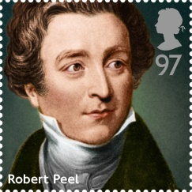Case study: The reforms of Robert Peel

**Robert Peel**

* Was home secretary from 1822.
* Robert Peel was a particularly effective politician – well informed and skilful at seeing bills through **Parliament**.

Peel’s penal reforms (reforms to punishment) in the 1820s

* Peel wanted punishments to reform rather than to deter. He reformed the penal code by reducing the number of crimes punishable by death by 100.
* He also reformed prisons – he was sympathetic with prison reformers.
* He also brought in a more logical and organised system of punishment, in which the same crime was always punished the same way.

Peel persuaded **Parliament** to pass the ***1823 Gaols Act***. This said that:

* Prisoners should receive regular visits from prison chaplains
* Gaolers should be paid (so they would not need to make money from prisoners)
* Female prisoners should be watched over by female warders
* Prisoners were not to be held in chains or irons

The measures brought some improvement but had limited effect, as there were no paid inspectors to ensure the new laws were put into practice.

**Metropolitan Police Force form, 1829**

1826 – an economic downturn led to unemployment and poverty, which in turn led to a crime wave. Peel wanted to introduce a centralised system for keeping the peace. The first Metropolitan Police officers were appointed in September 1829.

**Criticisms of the new police force**

* Cartoons portrayed the police officers as poorly-trained and immoral
* The public were afraid that the new police force would oppress them
* Others were concerned about the cost

**Peel’s attempt to reduce opposition**

Peel and his police commissioners drew up and issued clear guidelines to all new police recruits. They included the following.

* *The basic mission for which the police exist is to prevent crime and disorder*
* *The test of police efficiency is the absence of crime and disorder, not the visible evidence of police action in dealing with it.*

Case study: The separate system at Pentonville Prison

Pentonville Prison was built in ***1842*** as a prototype where the ‘separate system’ could be tested. Under this system, prisoners were kept apart as much as possible. They lived in separate cells and stayed there for up to 23 hours a day.

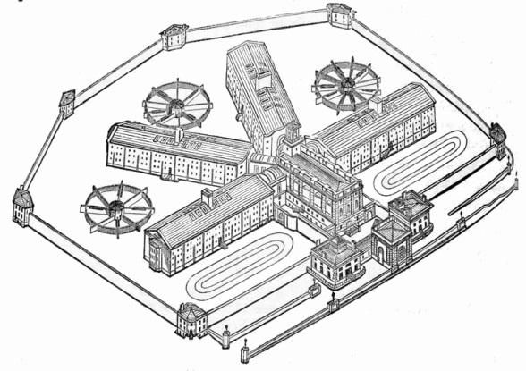**The building**

* Designed to support the separate system.
* The building had five wings with a base for staff in the central area. Each wing was made up of dozens of individual cells
* The cells had a floor area of just 4m by 2m. There was a small high window at the end to allow some natural daylight in.
* Cells contained a small basin for washing and a basic toilet. These improved the health and living conditions of the prisoners, but also ensured that they would not have the chance to see or speak to each other.

Living conditions

* Highly disciplined. Prisoners were fully isolated e.g. they worked in their cells.
* The work was deliberately very boring and repetitive: for example, oakum picking, which involved unravelling and cleaning old rope.
* 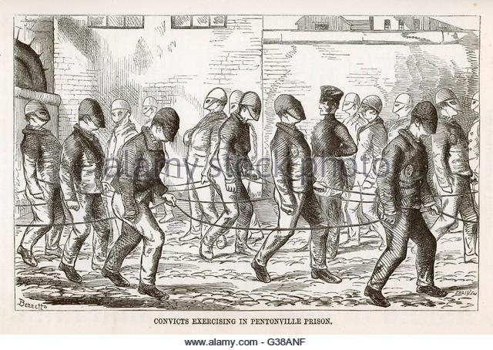Short periods of exercise or to going to the chapel were allowed. Face masks were worn for exercise, and in chapel they sat in individual cubicles wearing masks made of brown sacking.

The solitary conditions and lack of human contact meant many prisoners suffered from mental illness, including depression and psychosis. There was also a high rate of suicide.

Crime and Punishment: c.1900 – present day

*What you need to cover:*

|  |  |
| --- | --- |
| Crimes | Continuity and change in the nature of crimes against the person, property and authority, including new forms of theft and smuggling.  Changing definitions of crime, including driving offences, race crimes and drug crimes. |
| Punishments | The abolition of the death penalty; changes to prisons, including the development of open prisons and specialised treatment of young offenders; the development of non-custodial alternatives to prison. |
| Law enforcement | The role of the authorities and local communities in law enforcement, including the development of Neighbourhood Watch. Changes within the police force: increasing specialisation, use of science and technology and the move towards prevention. |
| Case studies | The treatment of conscientious objectors in the First and Second World Wars.  The Derek Bentley case: its significance for the abolition of the death penalty. |

Background and trends

In the **20th century**, society changed in many ways that affected crime, punishment and law enforcement. ***The role of the government in people’s lives grew***, largely as a result of the First and Second World Wars, and ***the role of the state in enforcing the law also grew***. ***Social attitudes changed dramatically during the 20th century***,which impacted heavily on how crimes were defined. This led to some activities being decriminalised, while others were made illegal for the first time – so creating new crimes.

Crime detection and prevention during this period changed significantly as a result of ***developments in science and technology***. New communications technologies, in particular, have had an important impact on the types of crime carried out and on crime detection.

***Changing attitudes about the rehabilitation of offenders***, as well as ***greater concern for the welfare of more vulnerable groups of offenders***, in particular young people, has also been an important feature of this period.

Crime, c.1900-present

The 1960s was a time of fast changing social attitudes. Some activities which were formerly crimes were decriminalised, while other activities were newly defined as crimes.

**Changing definitions of crime**

**Homophobic crime - *a new crime***

* Homosexuality was illegal in the UK until 1967
* Increasingly liberal attitudes towards sex during the 1960s led to change
* ***1967 Sexual Offences Act*** decriminalised homosexuality for men aged over 21
* ***2005 Criminal Justice Act*** meant that hate crimes (e.g. attacking someone because they were a homosexual) could be treated more severely than other crimes

**Race crime - *a new crime***

* For the first half of the twentieth century Britain wasn’t very multicultural
* During the 1950s, many people from the Commonwealth countries moved to Britain to work. New laws needed in order to ensure that they were treated fairly.
* ***1968 Race Relations Act*** made it illegal to refuse jobs, housing or public services to anyone on the basis of their race or ethnicity.
* ***2006 Racial and Religious Hatred Act*** defined spreading racial or religious hatred as a crime.

**Domestic violence - *a new crime***

* During the 19th century (1800s), the view of society was that men were the dominant partner in relationships. This was reflected in the law – it was believed that it was nobody else’s business if a husband wanted to be violent towards his wife.
* Attitudes changed during 20th century (1900s). The campaign for women’s votes, women’s contribution to the First and Second World Wars etc all influenced society’s views.
* ***1976 Domestic Violence Act*** gave victims the right to ask for an injunction (an order from court ordering them to stay away) against a violent partner.
* ***1991*** – it became possible to prosecute a husband for raping his wife.
* ***2014*** – controlling and coercive behaviour towards a partner became a crime.

**Abortion – *ceased to be a crime***

* Until 1967, terminating a pregnancy was illegal in Britain, apart from a few very strict medical reasons (e.g. the mother’s life was in danger).
* Liberalisation of attitudes in the 1960s led to the law being changed.
* People were also concerned about the health risks of backstreet (illegal) abortions
* ***1967 Abortion Act*** legalised abortion if the child was going to have severe disabilities or if the mother was at risk of physical/mental harm if the pregnancy continued.

**Attitudes towards social crimes**

* Social crimes = crimes that many people in society accept to some degree. E.g. tax evasion, using illegal drugs, copyright theft, minor driving offences.
* Smuggling and poaching have been social crimes for centuries. Smuggling still exists today and is still a social crime e.g. buying tax-free cigarettes or alcohol that has been smuggled.

**Drink driving/speeding used to be social crimes, but aren’t any longer.**

* As late as the 1970s it was considered normal to drive home after drinking large quantities of alcohol
* Government advertising campaigns since the 1970s have highlighted the risks of drink-driving
* Attitudes have therefore changed – drink driving and speeding are generally condemned by the public.

**Drug-taking is a controversial social crime**

* 1971 Misuse of Drugs Act made many drugs illegal.
* Some people think that drugs should be legalised – they think this would help with dealing with crimes linked to drug-dealing e.g. sex trafficking and gang violence.
* Others think that taking drugs should be a personal choice.

**New opportunities for old crimes**

**Terrorism**

* Terrorism is the use of violence, fear and intimidation to publicise a political cause.
* The **Gunpowder Plot** in the **17th century** would be considered **terrorism today**.
* Terrorism in more recent years has included the IRA (Irish Republican Army) which fought for Ireland’s political independence from the rest of the UK during the 1970s-80s, and Al-Qaeda and ISIS.
* Modern-day terrorists use the internet to communicate and spread their message.
* **People trafficking**
* This involves people from poorer countries being brought to the UK and being forced to work for very low wages, or no wages at all. Some women and children are forced into prostitution. Often criminal gangs control these people using physical confinement, blackmail, coercion and fear.
* Poor girls were sometimes sold into prostitution during the 19th century (1800s) also – the crime was given the nickname of the ‘white slave trade’.

**Cybercrime**

* Any crime that is carried out using the internet and other digital technologies.
* New technologies allow criminals to commit old crimes on a much bigger scale than in the past, because the internet gives them access to people and businesses around the world.

1. **Fraud**

* Impersonating other people or businesses to make money illegally – for example, posing as a bank or charity in order to get hold of an individual’s bank details and steal their money.
* In the past this would have been done by approaching an individual and tricking them into revealing their details.
* Today, however, it can be done by sending an email to a large number of people, and hoping that a few will reply with their bank or credit card details.

1. **Copyright theft**

* Copyright is the right of an artist or company to be recognised – and paid – as the creator of their work. Copyright applies to books, music, films and games.
* Earlier in the 20th century copyright theft could involve making a photocopy, or a cassette or video recording, without paying the creator.
* In the 21st century, copyright theft is committed when people make available illegal downloads of music, computer games, films and television shows.
* The internet makes it much easier for people to access a huge selection of media more quickly and easily than ever before.

1. **Extortion**

* Extortion involves making someone pay money by using threats or blackmail.
* In the past, this may have been done using letters, the telephone or in person.
* Nowadays, the internet enables criminals to make their threats on a wider scale, as they are able to communicate easily with people around the world. Some criminals extort money by threating to hack businesses’ computer systems and databases unless they pay.

Law enforcement, c.1900-present day

**Developments in policing since 1900**

* In 1900, every area across Britain had its own police force. The 200 separate forces had no central records on crime or criminals, and rarely shared information or worked together.
* Policemen travelled on foot and used a whistle to raise the alarm.

**During the 20th century, policing changed in many ways:**

* 1920s, women first recruited to join the police force (at first they just worked with women and children)
* 1947, Police Training College set up in order to train new recruits
* Increased use of science and technology
* **Technology used to prevent crime:** CCTV cameras; mass video surveillance (used to forecast acts of terrorism and other crimes)
* **Technology used to solve crime:** Forensic science e.g. Fingerprint branch set up in 1901 (kept fingerprint records of everyone arrested), DNA samples used to convict murderers, 1988; improved computer software used to analyse video data to identify criminals

**Increasing police specialisation**

**Fraud squad**

* ***First specialist Fraud Squad was set up in 1946*** in London, to tackle crime in business and the stock market
* Required officers to have expert knowledge of finance and business
* Evolved to tackle other high-value crimes like art theft as well.

**Specialist drug-trade units**

* ***National Crime Agency was set up in 2013***, to tackle drug-trafficking in the UK and large-scale drug production within the UK.
* Uses intelligence and data on known criminal groups to predict and stop drug hauls, and to disrupt supply networks for drugs manufactured within the UK.
* All local police forces have special squads to deal with drug dealers in their area.

**Dog handling units**

* Specialist dog section established within the Met Police in 1946. Most police forces had dog units by the 1950s.
* Dogs trained to: sniff out drugs, find explosives, track and catch criminals etc.

**Special branch**

* Every police force has its own Special Branch to tackle threats to national security and terrorism. They work with MI5 to detect and prevent terrorists.
* Methods include extensive surveillance techniques, with the aim of intercepting possible terrorist attacks.

**Crime prevention**

* In the 21st century, focus within law enforcement has been on preventing crime before it even happens.
* This can involve things such as working with schools and offering people advice on making their homes secure
* Other methods of preventing crime include creating risk and threat assessments (making predictions of where crimes might occur and who the criminals might be) and Police Community Support Officers, who work on stopping anti-social behaviour.

Neighbourhood Watch

* 1980s, the prime minister, **Margaret Thatcher**, led a Conservative government that wanted to increase the responsibility of the individual in society and reduce the role of the state.
* 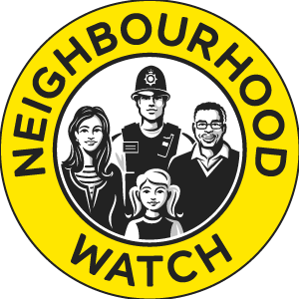***First Neighbourhood Watch scheme was set up in 1982***. A Neighbourhood Watch is a local committee of people who raise awareness about crime.
* Aims include: helping the police to prevent crime by encouraging neighbours to keep an eye on each other’s property; reducing fear of crime; reporting crime trends to the police.
* Some people believed the scheme made positive changes e.g. people felt safer; it helped the role of the police
* Others saw it as an excuse to underfund the police force, and felt frustrated at poorer areas being less likely to have a Neighbourhood Watch scheme.

**Punishments, c.1900-present day**

**Abolition of the death penalty**

Death penalty used less and less from the beginning of the 19th century (1800s) – by 1830 murder and treason were the only crimes punished with the death penalty. Despite early attempts by politicians failing, the death penalty had been abolished by the mid-20th century.

**Key dates**

* Early 1950s: about 15 people executed a year
* ***1957 Homicide Act*** restricted death penalty to the most serious cases of murder (capital murders)
* ***1965 Murder Act***, suspended the death penalty for murder for five years
* ***1969 Murder Act amendment***, made the 1965 Act permanent.

*A few crimes continued to carry the death penalty, but it was never used after this point. The death penalty was ended for all crimes in 1998.*

**The role of government**

* Opinions about the death penalty were strongly divided - the House of Lords blocked two attempts from the Commons to abolish the death penalty during the 1940s and 50s.
* The Home Secretary in 1965 was Roy Jenkins – his influence is often seen as playing a key role in the death penalty being abolished

**Changing attitudes**

* Increasing belief that vulnerable people shouldn’t be punished so severely.
* ***1908 Children’s Act*** said that under-16s couldn’t be sentenced to death
* ***1933 Young Person’s Act*** raised the age limit to 18
* ***1922 Infanticide Act*** protected women who killed their child shortly after birth – recognised that their mental state could be affected by pregnancy and childbirth
* **Liberalisation of attitudes** during the 1960s - society willing to change its mind on how things had been done before.

**Controversial executions**

|  |  |  |
| --- | --- | --- |
| **1950** | Timothy Evans | Hanged for murdering wife and baby. Later evidence showed that he was innocent. |
| **1953** | Derek Bentley | Hanged for murder of a police officer. Had learning difficulties and a low mental age. |
| **1955** | Ruth Ellis | Hanged for the murder of violent boyfriend who had been abusing her. |

**Changes in the prison system**

Keeping criminals in prison is very expensive, and reoffending rates are very high. A trend of this period is therefore the questions asked about how prison should be used in modern society.

**New ideas led to new developments in prisons**

|  |  |
| --- | --- |
| New idea | Practical outcomes |
| “Mentally ill prisoners should be treated separately to other prisoners.” | 1896, Broadmoor Hospital opened. |
| “There should be alternatives to prison.” | 1907, Probation officers employed to check on offenders living outside prison. |
| Increased focus on prisoner welfare. | 1922, Separate system ended in prisons.  Educational opportunities offered. |
| New focus on preparing prisoners for life after serving their sentence. | 1933, First open prison at New Hall, Wakefield. Prisoners allowed out on day release to work and prepare for reintegration into society. |

Young people began to be treated differently

Borstals

* 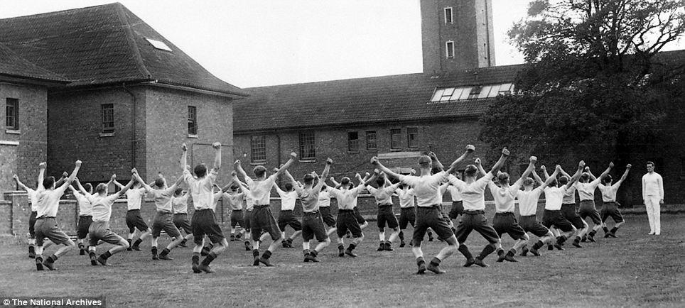In 1902, an experiment was set up in Kent – the first borstal. This was a prison for boys only, and its purpose was to ensure that young convicts were kept entirely separate from older criminals.
* ***1908 Prevention of Crime Act*** ordered similar places to be set up, with focus being given to education rather than punishment.
* Courts were given the power to sentence young people of fifteen to twenty-one years who committed serious crimes, or who persistently escaped from approved schools, to be sent to them for six months to two years.
* The day was very structured and disciplined, and the inmates took part in physical exercise, education, and learning programmes which focused on practical skills.
* Some estimates suggest that reoffending rates were about 30% in the 1930s, compared to about 60% in the present day.

Youth reforms in 1940s

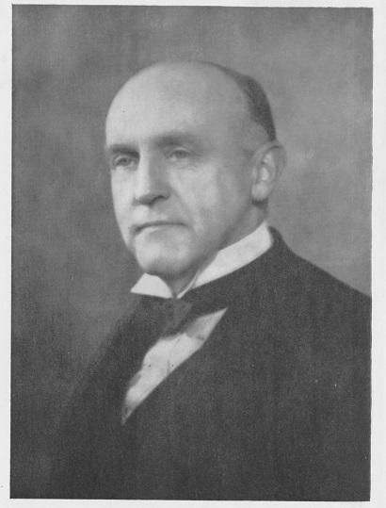

**Alexander Paterson**

* New Labour Government after Second World War. They introduced many radical welfare and social reforms, including reforms to the youth justice system.
* The prisons commissioner, Alexander Paterson, was very influential also in changing how younger offenders were treated – he argued that probation and rehabilitation were essential.

A good example of new focus on rehabilitation: the ***1948 Criminal Justice Act***. It introduced:

* A graduated system of prison, depending on the seriousness of the crime and the offenders record
* Attendance centres for young people who had committed minor crimes – young offenders attended the centres at weekend for rehabilitation, instead of being detained all week

**Youth justice reforms in 1960s – focused on treatment of young people in court**

The ***1963 Children and Young Persons Act***

* Focused on the importance of caring for and protecting young offenders and raised the age of criminal responsibility from eight to ten years.

The ***1969 Children and Young Persons Act***

* Encourages care orders, and supervision by probation officers and social workers, over prison sentences.

**Increasing use of alternative punishments to prison**

The increasing focus on rehabilitation has led to alternative punishments being used, rather than sending people to prison. For example:

* **Anti-social behaviour orders**. A court order that places restrictions on what a person can do.
* **Community service**.People convicted of minor offences are ordered to do supervised work to improve their local community.
* **Electronic tagging**. The court orders a person convicted of a crime to wear an electronic tag. Using the tag, they monitor the criminal’s movements, allowing their movements to be controlled.

Case study: Conscientious Objectors in the First and Second World Wars

1914, the beginning of the First World War. For the first two years of the war men could choose if they wanted to fight or not. This changed in 1916.

***1916 – Military Service Act*** passed. Conscription introduced – it was now illegal to avoid taking an active part in the war. Controversial in parliament.

* March 1916 – all unmarried men aged 18-41 called up to fight
* May 1916 - married men as well
* 1918 – upper age limit increased to 51

Some men refused to fight because they said that their conscience wouldn’t allow it – Conscientious Objectors (COs).

* **Absolutists**: People who believed that even indirect support for the war was wrong. They were often also pacifists (people who believe that all violence is immoral).
* 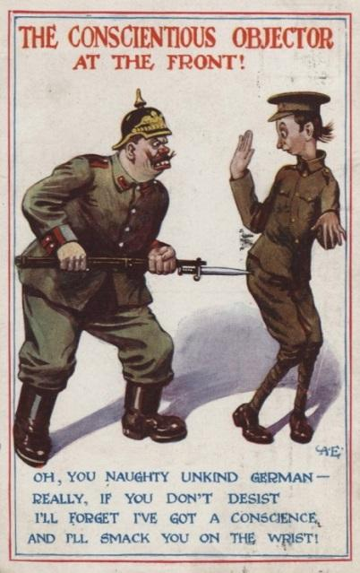**Alternativists**: People who refused to fight, but would support the war effort in other ways e.g. stretcher bearers.

COs could appear before a tribunal which judged if their claims for exemption were genuine. Tribunals were held locally, so there was wide variation from area to area. They were often also made up of older people, who felt that the young men should certainly be fighting.

Treatment of COs

* Many absolutists were imprisoned. Sometimes they faced solitary confinement. The authorities hoped this would weaken their determination.
* Some COs were punished by being sent to France, to the front line of the fighting. Once there, they were given orders, and if they refused to follow them they were sentenced by a military court. A small number were sentenced to death.
* Some COs and their families were isolated by friends and neighbours. Some received hate mail or white feathers in the post as a symbol of cowardice.

*The government needed to recruit lots of men to fight. They hoped that treating the COs harshly would prevent lots of other men joining them. They used the press to spread the idea that refusing to fight was ‘unmanly’, and also to widely publicise the harsh punishments handed out to COs.*

Changes in treatment of COs during the Second World War

* During the Second World War (1939-45), COs were offered alternative occupations such as farm work. Prison was generally used as a last resort.
* However, the authorities still expected people to support the war and used lots of propaganda to build support.
* Those who actively campaigned against the war could find themselves in court e.g. the Peace Pledge Union were put on trial for putting up anti-war posters.

Attitudes towards COs during Second World War

* During the Second World War, **official attitudes** to COs were quite different from the First World War. In the Second World War people were being asked to unite against Hitler as a tyrant, and Nazism as a movement that persecuted minorities. In this context, harsh punishments for COs would have been seen as hypocritical.
* On the other hand, **public opinion** could still be **hostile** towards those who refused to fight. Some COs were attacked or lost their jobs.

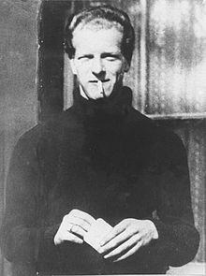Case study: The Derek Bentley case and the abolition of capital punishment

The story

* 2nd November 1952, Derek Bentley (18 years) and Christopher Craig (16 years) attempted to burgle a warehouse.
* Police are called to the warehouse. Craig taunted the police before Detective Sergeant Frederick Fairfax climbed the drainpipe and grabbed hold of Bentley.
* Fairfax asks Craig to "Hand over the gun, lad" and Bentley shouted the ambiguous phrase "Let him have it, Chris" to Craig. Craig fired his revolver at Fairfax, striking him in the shoulder.
* A group of uniformed police officers arrived and was sent onto the roof. The first to reach the roof was Police Constable Sidney Miles, who was immediately killed by a shot to the head.

The case for and against Bentley being sentenced to death

|  |  |
| --- | --- |
| Prosecution | Defence |
| * Bentley shouted *‘Let him have it’.* This made him jointly responsible for the murder because he encouraged Craig. * Bentley had a history of criminality – had been in youth detention. * He had a low level of intelligence but was not insane – he was aware of and responsible for his actions. | * Questions over what *‘Let him have it’* meant, and whether he even said it. * Bentley didn’t have a weapon. Handed himself over to the police. * Bentley had a learning difficulty and a **mental age of 10**. |

Impact of the case

Public opinion

* On the night of the execution, 5000 protestors met outside Wandsworth Prison changing, ‘Murder!’. Protestors ripped down and burned the death notice posted on the prison gates.
* Bentley’s family used the media to promote their cause. The case became widely known through songs, books and films.
* He was eventually pardoned in 1993, and the entire conviction was overturned in 1998.

Parliament

* 200 MPs supported a parliamentary motion calling for Bentley’s reprieve, but before they could debate it the death sentence had been carried out.
* ***1957 Homicide Act*** made allowances for defendants suffering from diminished responsibility (not being fully in control of your actions, for example, because of a mental illness), or who had been abused by the person they’d murdered – the murder charge would be reduced to manslaughter.
* ***1965 Murder Act*** suspended the death penalty for murder. This was made permanent in **1969**.