**Revision Strategies: Science Combined AQA 8464**

**Paper 1 Mocks – What is assessed?**

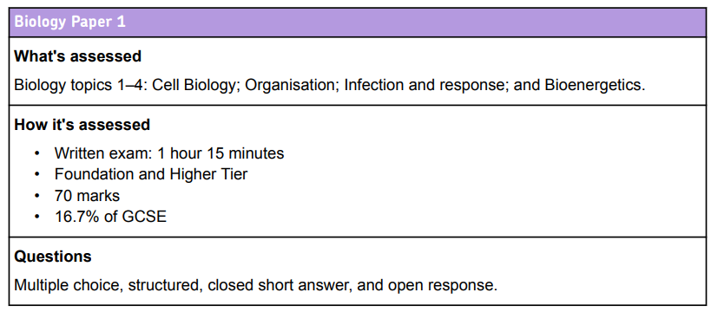

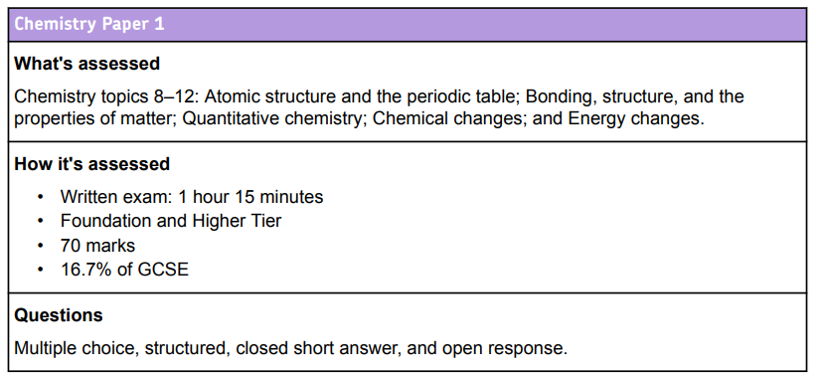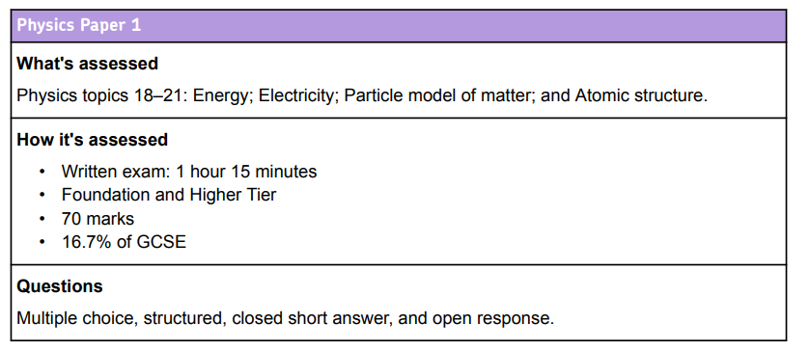

**Flashcards**

* On one side of your flashcard, write the question
* On the other side, write the answer in bullet points.

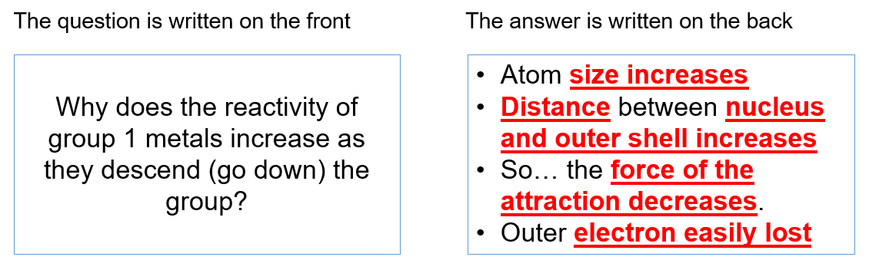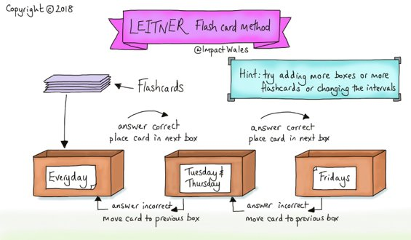

Use the flash cards to regularly revisit topics. Ask yourself the questions then say or write down your answer. Use the answer on the back to check your understanding. If you got it correct, place the card in the ‘secure’ pile, if it was incorrect place it in the ‘insecure’ pile. Once you have worked through all the cards, revisit the insecure pile until they are all on the secure pile.

**Complete Past Paper Exam Questions**

Use the drop down menu to select the following:

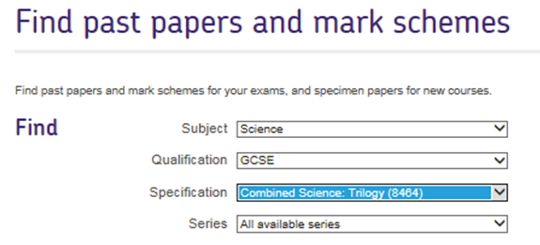

Use past papers and mark schemes available to familiarise yourself with examination style questions.

Complete the questions and then use the mark schemes to correct your work.

Focus on what the marks are awarded for and the key terminology examiners look for.

Or bring in for your teacher to mark.

**Look, Write, Cover, Check**

* Read a piece of information from your revision guide/notes
* Cover it with something
* Try to write it down accurately from memory
* Check against the revision guide, correct errors and fill gaps
* Repeat until you can write the information down accurately.

**Other Resources**

* **Websites** – BBC Bitesize, Seneca, GCSEScienceRevision.com
* **YouTube** – Free Science Lessons, Cognito, Fuse School
* **Instagram** - @HuddiesStudies
* **Apps** – PhysQuiz, BioQuiz, Quizlet

    
**GCSEScienceRevision BBC Bitesize Seneca PhysQuiz**



**Quizlet BioQuiz AQA Past Papers**

**Important Dates:**

**Paper 2 Examinations:**

Biology Paper 2: Friday 9th June 2023

Chemistry Paper 2: Tuesday 13th June 2023

Physics Paper 2: Friday 16th June 2023

**Paper 1 Examinations:**

Biology Paper 1: Tuesday 16th May 2023

Chemistry Paper 1: Tuesday 23rd May 2023

Physics Paper 1: Thursday 25th May 2023

